Curriculum Framework for -Year Undergraduate Multidisciplinary Programme (Honours) & Master Programme in Colleges and Universities of Karnataka State Under NEP 2020.

5th and 6th Semester Syllabus for BA in Women’s Studies

MANGALORE UNIVERSITY
Listing of Courses from I to VIII Semesters for the Four-Year Undergraduate Program (FYUGP) in WOMENS STUDIES

Sem. No. | Course Category | Course Code | Course Title | Credits Assigned | Instructional hours per week |  | Duratio n of Exam  (Hrs.) | Exam/ Evaluation Pattern (Marks)
 |  |  |  |  | Theory | Practical | Duratio n of Exam  (Hrs.) | IA | Exam | Total
I | DSC | WS C1 | Understanding Gender | 3 | 3 |  | 2 | 40 | 60 | 100
I | DSC | WS C2 | Emerging Gender issues | 3 | 3 |  | 2 | 40 | 60 | 100
II | DSC | WS C3 | Mapping Women’s Movements | 3 | 3 |  | 2 | 40 | 60 | 100
II | DSC | WS C4 | Gender, Economy and Work | 3 | 3 |  | 2 | 40 | 60 | 100
III | DSC | WS C5 | Revisiting History: Feminist Perspectives | 3 | 3 |  | 2 | 40 | 60 | 100
III | DSC | WS C6 | Waves of Feminist Theories | 3 | 3 |  | 2 | 40 | 60 | 100
IV | DSC | WS C7 | Gender and Society | 3 | 3 |  | 2 | 40 | 60 | 100
IV | DSC | WS C8 | Doing Feminist Research | 3 | 3 |  | 2 | 40 | 60 | 100
V | DSC | WS C9 | Gender and Development | 4 | 4 |  | 2 | 40 | 60 | 100
V | DSC | WS C10 | Feminist Jurisprudence | 4 | 4 |  | 3 | 40 | 60 | 100
V | DSC | WS C11 | Feminist Counselling-1 (with Practical) | 4 | 2 |  | 2 | 50 | 50 | 100
V | DSE | WS E1  (Anyone to be chosen) | - Education: Gender Perspective  - Gender Construction in Folk Culture | 3 | 3 |  | 2 | 40 | 60 | 100
V | Vocational | WS V1  (Anyone to be chosen) | Gender Entrepreneurship and Skill Development | 3 | 3 |  | 2 | 50 | 50 | 100

VI | DSC | WS C13 | Understanding Empowerment from Feminist Perspectives | 4 | 4 |  | 2 | 40 | 60 | 100
VI | DSC | WS C14 | Indian Feminisms | 4 | 4 |  | 2 | 40 | 60 | 100
VI | DSC | WS C15 | Micro-finance and Self-help Group Management | 4 | 4 |  | 2 | 40 | 60 | 100
 | DSE | WS E2  (Anyone to be chosen) | - Feminization of Poverty  - Gendering Food and Nutrition C.  D. | 3 | 3 |  | 2 | 40 | 60 | 100
 | Vocational | WS V2  (Anyone to be chosen) | A. Women in Live-stock management (With Practical)  B.  C. | 3 | 2 | 1 | 2 | 50 | 50 | 100
 | B.A. (Honours) in WS with X as Minor and Y as Vocational Subject (without Research Project)
VII | DSC | WS C16 | Gender sustainable Development and Environment | 4 | 4 |  | 2 | 40 | 60 | 100
VII | DSC | WS C17 | Feminist Counselling -2 (With Practical) | 4 | 4 |  | 2 | 50 | 50 | 100
VII | DSC | WS C18 | Conceptualizing Gender-based violence and Resistance | 4 | 4 |  | 2 | 40 | 60 | 100
VII | DSC | WS C19 | Research Methodology, Social Statistics in Feminist Research | 4 | 4 |  | 2 | 40 | 60 | 100
 | DSE | WS E3  (Anyone to be chosen) | - Computer Application in Women’s Studies Research  - Gender Construction in Language and literature | 3 | 3 |  | 2 | 40 | 60 | 100
 | Vocational | WS V3  (Anyone to be chosen) | A. NGO/ CSO Management  B Engendering Human Resource Management  C. | 3 | 3 |  | 2 | 40 | 60 | 100

VIII | DSC | WS C20 | Gender Analysis Tools and Techniques | 4 | 4 |  | 2 | 40 | 60 | 100
VIII | DSC | WS C21 | Gender Culture and Mass Media | 4 | 4 |  | 2 | 40 | 60 | 100
VIII | DSC | WS C22 | Locating Gender in Karnataka: Issues and Challenges | 4 | 4 |  | 2 | 40 | 60 | 100
VIII | DSC | WS C23 | Internship/Apprentice ship | 4 | 4 -6 weeks (Report & Viva) |  |  | 50 | 50 | 100
 | DSE | WS E4  (Anyone to be chosen) | - Engendering Governance and Public Policy  - Gerontology and Geriatric Care C. | 3 | 3 |  | 2 | 40 | 60 | 100
 | Vocational | WS V4  (Anyone to be chosen) | A. Project Management and Extension Activities  B.  C. | 3 | 3 |  | 2 | 40 | 60 | 100

 | B.A. (Honours with Research Project) in WSnomics with X as Minor and Y as Vocational Subject
VII | DSC | WS C17 | Gender sustainable Development and Environment | 4 | 4 |  | 2 | 40 | 60 | 100
VII | DSC | WS C18 | Feminist Counselling -2 (With Practical) | 4 | 4 |  | 2 | 50 | 50 | 100
VII | DSC | WS C19 | Conceptualizing Gender-based violence and  Resistance | 4 | 4 |  | 2 | 40 | 60 | 100
VII | DSC | WS C20 | Research Methodology, Social Statistics in Feminist Research | 4 | 4 |  | 2 | 40 | 60 | 100
 | DSE | WS E3  (Anyone to be chosen) | - Computer Application in Women’s Studies Research  - Gender Culture and Mass Media  - Gender Construction in Language and literature  - Locating Gender in Karnataka: Issues and Challenges | 3 | 3 |  | 2 | 40 | 60 | 100

 | Vocational | WS V3  (Anyone to be chosen) | A. NGO/Civil Society Management  B Understanding Human Resource Manage ment from Gender Perspectives  C. | 3 | 3 |  |  | 2 | 40 | 60 | 100
VIII | DSC | WS C21 | Gender Analysis Tools and Techniques | 4 | 4 |  |  | 2 | 40 | 60 | 100
VIII | DSC | WS C22-  RP | Field-based Research Project with viva | 10+2* | 24 | Project Report &Viv |  |  | 150 | 150 | 300
 | DSE | WS E4  (Anyone to be chosen) | - Engendering Governance and Public Policy  - Gerontology and Geriatric Care C. | 3 | 3 |  |  | 2 | 40 | 60 | 100
 | Vocational | WS V4  (Anyone to be chosen) | A. Project Management and Extension Activities  B.  C. | 3 | 3 |  |  | 2 | 40 | 60 | 100

Honours students with research project shall initiate the project work in the seventh semester with literature survey, review and project proposal formulation, complete these works by the end of the 7th semester which shall be evaluated for 2-credits and counted in the 8th semester. Students shall start the actual project work, immediately after the close of the 7th semester examinations. They should submit the Project Report/Dissertation by the end of the 8th semester.
Open Electives for non-Women Studies Students are also to designed and contents drafted for the first three semesters with multiple options.
Note: If any Elective or Vocational course involves theory-cum-practical, then IA to Exam. Marks will be in the ratio of 50:50. The practical part is to be evaluated as part of IA. Semester end examination is only in theory component and questions from practical part, if any.

MANGALORE UNIVERSITY
Listing of Courses from I to IV Semesters Open Elective courses for the Four-Year Undergraduate Program (FYUGP) in WOMENS STUDIES for NON -WOMENS STUDIES Students

Sem. No. | Course Category | Course Code | Course Title | Credits Assigned | Instructional hours per week |  | Duratio n of Exam  (Hrs.) | Exam/ Evaluation Pattern (Marks)
 |  |  |  |  | Theory | Practical | Duratio n of Exam  (Hrs.) | IA | Exam | Total
I | OE | WS OE1 | Understanding Gender | 3 | 3 |  | 2 | 40 | 60 | 100
I | OE | WS OE2 | Capasity Building for Gender Practitioneres | 3 | 3 |  | 2 | 40 | 60 | 100
II | OE | WS OE3 | Women’s Human Rights | 3 | 3 |  | 2 | 40 | 60 | 100
II | OE | WS OE4 | Doing Field Research with Gender Perspectives | 3 | 3 |  | 2 | 40 | 60 | 100
III | OE | WS OE 5 | Gendering Disability | 3 | 3 |  | 2 | 40 | 60 | 100
III | OE | WS OE 6 | Gender, Culture and Mass Media | 3 | 3 |  | 2 | 40 | 60 | 100
IV | OE | WS OE7 | Gender, Health and Sexualities | 3 | 3 |  | 2 | 40 | 60 | 100
IV | OE | WS OE 8 | Gender Analysis Tools and Techniques | 3 | 3 |  | 2 | 40 | 60 | 100

3rd YEAR (5th and 6th Semester) UG – WOMEN’S STUDIES
Course Patterns, Schemes of Examinations and Credit for BA Women’s Studies Under NEP

Paper | Paper Code | Course Title | Credits | IA  Marks | SA  Marks | Total
Semester - V
1. | WS C-9 | Gender and Development | 4 | 40 | 60 | 100
2. | WS C-10 | Feminist Jurisprudence | 4 | 40 | 60 | 100
3. | WS C-11 | Feminist Counselling-1 | 4 | 50 | 50 | 100
 |  | (Theory + Practical) | (2+2) | (10
 |  | 2 credits theory+ 2credits |  | theory +
 |  | practical) |  | 40
 |  |  |  | practical)
4. | WS E-1A | Education: Gender Perspective | 3 | 40 | 60 | 100
5. | WS E-1B | Gender Construction in Folk Culture | 3 | 40 | 60 | 100
6. | WS V-1A | Gender Entrepreneurship and Skill Development | 3 | 40 | 60 | 100

Paper | Paper Code | Course Title | Credits | IA Marks | SA  Marks | Total
Semester-VI
1. | WS C-12 | Understanding Empowerment from Feminist Perspectives | 4 | 40 | 60 | 100
2. | WS C-13 | Indian Feminisms | 4 | 40 | 60 | 100
3. | WS C-14 | Micro-finance and Self- help Group Management | 4 | 40 | 60 | 100
5. | WS E-2A | Feminization of Poverty | 3 | 40 | 60 | 100
7. | WS E-2B | Gendering Food and Nutrition | 3 | 40 | 60 | 100
8. | WS V-2A | Women in Live-stock | 3 | 50 | 50 | 100
 |  | management | (1+2) | (10 theory
 |  | (Theory + Practical) |  | + 40
 |  | 2 credits theory+ 1credits |  | practical)
 |  | practical)
9. | Internship |  | 2

Curriculum of

BA Honours in
Women’s Studies

(5th & 6th Semester)

Karnataka State Higher Education Council

MANGALORE UNIVERSITY

Curriculum
Program Name | BA in Women’s Studies |  |  | Semester | Fifth Semester
Course Title | Gender and Development (Theory)
Course Code: | WS C-9 |  | No. of Credits |  | 4
Contact hours | 60 Hours |  | Duration of SEA/Exam |  | 2 hours
Formative Assessment Marks |  | 40 | Summative Assessment Marks |  | 60

Course Objectives: | - This course aims at uncovering the gendered nature of development.  - The course will familiarize the students with the discourse of the inclusion of Women in the developmental paradigm from a gender perspective.  - To course intend to emphasize the need for collecting, incorporating, and analyzing data on women and development from a gender perspective;  - The course aims to educate the students on the need for gender planning and gender budgeting
Content: | Unit-1 | Introduction to Gender and Development | 15hrs.
Content: | Unit-1 | Chapter-1  Meaning and Definitions Development. Traditional models of development, from growth-centered development to human development, | 15hrs.
Content: | Unit-1 | Chapter-2 Gender Equity and Equality, Gender Roles and Gender Needs, Community Need, Practical Gender Need, and  Strategic Gender Needs | 15hrs.
Content: | Unit-1 | Chapter-3 Gender Analysis Framework:  Definition, Meaning, and Objectives of Gender Analysis; Gender Analysis as a Tool for Development, Harvard Analytical Framework; Caroline Moser’s Gender Planning Frame Work; Rani Parker’s Gender Analysis, Matric, and Sara Longwe: Women Empowerment Frame Work; Nailla Kabeer’s Social Relations Frame Work. | 15hrs.
Content: | Unit-2 | Approaches to Women’s Development | 16hrs
Content: | Unit-2 | Chapter-1 Paradigm shift from women’s welfare to development as a process of gender equality and women’s empowerment:  WID, WAD, GID, GAD, the DAWN perspective  the capability approach by Amartya Sen and Martha Nussbaum | 16hrs

Chapter-2 Gender Action Plan:
From MDG to SDG
Sustainable Development Goal Targets.
 |  | Chapter-3 Gender and economic rights: Property rights and access to resources, Women, Agriculture and Rural Development, Gender and Labor market participation, Gender wage gap, Gender, and the care economy, Women’s entrepreneurship, The gendered impact of financial and food crises, Gender and migration.
 | Unit-3 | Indicators of Development-Global Perspectives | 14hrs
 | Unit-3 | Chapter-1 Human Development Index (HDI), Gender Development Index (GDI), Gender Empowerment Measure  (GEM), Gender Inequality Index (GII) | 14hrs
 | Unit-3 | Chapter-2 The impact of Globalization and Structural Adjustment Policies (SAP) on Women with particular reference to India, in the fields of - Education, Health, Agriculture, Organized Sector, and Unorganized Sector | 14hrs
 | Unit-4 | Engendering Policy and Planning | 15hrs
 | Unit-4 | Chapter-1 Strategies of Gender Mainstreaming; Gender Auditing and Gender Budgeting; Gender Mainstreaming in Implementation of Women Development Project, Gender Equality Action Planning and Project Design; Implementation,  Monitoring, and Evaluation. | 15hrs
 | Unit-4 | Chapter-2 Ministry of Women and Child Development, Role of Niti Aayoga, Role of NGOs and CSOs in Women  Development. | 15hrs
 | Unit-4 | Chapter-3 Development Model Focusing on Socially excluded women in India | 15hrs
Pedagogy: | Lectures / Assignments/ Self-study/Role-play/ Poster and Album making/  Presentation/Film Review/Group readings and discussion.
Course Outcomes (CO’s) | CO1 | After completing the course, students can explain different frameworks for Gender Analysis and Gender Mainstreaming, tools for women’s development.
Course Outcomes (CO’s) | CO2 | Students will be able to interpret various indices developed to unearth gender inequalities at global and national levels;
Course Outcomes (CO’s) | CO3 | Students can design plans and policies for engendering women’s development.
- Chossudovsky, Michel, The Globalization of Poverty: Impacts of IMF and World Bank Reforms. Penang: Third World Network-1997.
- Evorett, Jana, Matson. (1979). “Women in Social Change in India”. Heritage Publication, New Delhi.

References/
Readings
  - Krishnaraj Maithrayee (ed), Gender, population and development, Oxford, New Delhi,1999
  - Kabeer, N., (2003) Gender Mainstreaming in Poverty Eradication and the Millennium Development Goals, the Commonwealth Secretariat. London.
  - Lilja, Nina and Dixon, John (2008) ‘Operationalising Participatory Research and Gender Analysis: New Research and Assessment Approaches. New York: Development in Practice.
  - March, C., Smyth, I. and Mukhopadhyay, M. (1999), A Guide to Gender-Analysis Frameworks. Great Britain: Oxfam.
  - Momsen, J.H. (2004), Gender and Development, Routledge: London.
  - Momsen, J.H. and Kinnaird, V. (1993), Different Places, Different Voices: Gender and Development in Africa, Asia and Latin America. London: Routledge.
  - Moser, A. (2005), Gender Mainstreaming Since Beijing: A Review of Success and Limitations in International Institutions. New York: Routledge.
  - Moser, C.O.N. (1993), Gender Planning and Development: Theory, Practice and Training. London: Routledge.
  - Parvathi Benu, What the Economic Survey 2022-23 says about gender inclusion in India, February 01, 2023.
  - IAWS. (1995). “Feminist Approaches to Economic Theories a Report”. IAWS, New Delhi.
  - Martha Nusbaum. “Women and capability approach – Gender perspective in social policy”. AmartyaSen’s. “Participation and development”.
  - UNDP, (2006), Human Development Report, Fighting Climate Change: Human Solidarity in A Divided World. New York: Palgrave

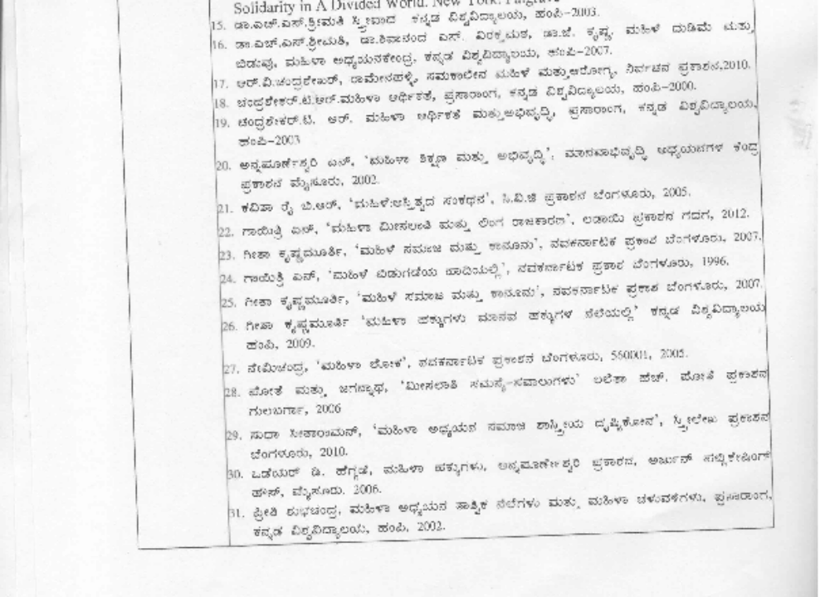

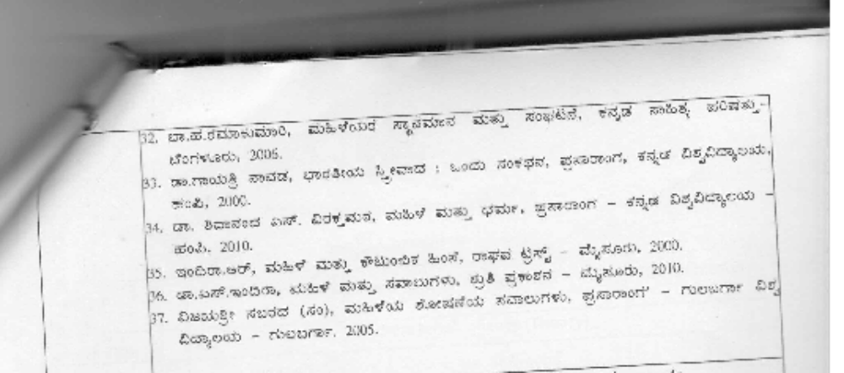

Assessment | Weightage | Nature of Assignments
Formative Assessment | 40% | Written term paper, Seminar  Presentation, 2 Periodic Tests
Summative Assessment | 60% | End Semester Examination

Date: Chairperson

Course Co-Ordinator

MANGALORE UNIVERSITY

Curriculum
Program Name | BA in Women’s Studies |  |  | Semester | Fifth Semester
Course Title | Feminist jurisprudence (Theory)
Course Code: | WS C-10 |  | No. of Credits |  | 4
Contact hours | 60 Hours |  | Duration of SEA/Exam |  | 2 hours
Formative Assessment Marks |  | 40 | Summative Assessment Marks |  | 60

Course Objectives: | - The course will help in understanding the discourse of Laws from feminist perspectives  - The course will enable the students to understand the constitutional and legal provisions available for gender justice  - The course will expose analytical skills and theoretical frameworks of feminist jurisprudence.
Content: | Unit-1 | Feminist jurisprudence | 16hrs.
Content: | Unit-1 | Chapter-1 Gender Justice: Private-public Dichotomy, Growth of Feminist Jurisprudence, Impact and Contribution of Feministic Jurisprudence, Different Schools of feminist  jurisprudence: Liberal, Cultural, Radical, and Post-modern | 16hrs.
Content: | Unit-1 | Chapter-2 Equality provisions in the Constitution of India  - Preamble, Fundamental Rights (Articles 14,15,16,21) and Directive Principles (Articles 37 -57), Enhancement of Fundamental Rights (Act 32, 226)  UN Convention for the Elimination of Discrimination against Women (CEDAW)  Women’s Rights and the Role of the Judiciary | 16hrs.
Content: | Unit-2 | Unequal position of women in personal laws and within  Families: an overview | 16hrs
Content: | Unit-2 | Chapter-1 Hindu, Muslim and Christian Laws: Marriage, Maintenance, Divorce & custody, and Property Rights, Debates  on Uniform Civil Code | 16hrs
Content: | Unit-2 | Chapter-2 sexuality and morality in law: Rape: 375, 376 Nirbhaya Act 2013, Laws on Adultery, Immoral Traffic Prevention Act 1956 read with section 370 IPC, Indecent Representation of Women (Prohibition) Act, POCSO, 1986, Transgender Persons (Protection of Rights) Act, 2019, Debate  on article 377(LGBTQI) | 16hrs

 |  | Chapter-3 Child Marriage Prohibition act 2006(Karnataka Amendment-2016), Dowry Prohibition Protection of Women from Domestic Violence Act, 2005, Prevention of Devadasis Act
 | Unit-3 | Economic Rights and Law | 14hrs
 | Unit-3 | Chapter-1 Labour Laws: Gender protective laws, Gender neutral laws, Gender corrective laws – Minimum Wages Act 1948, Factories Act 1948, Maternity Benefit Act-1976, Equal Remuneration Act 1976, New labour code bill (2022-23),  Medical Termination of Pregnancy Act, 1971 | 14hrs
 | Unit-3 | Chapter-2 Law Protecting Women against Sexual Harassment at Workplace - The Sexual Harassment of Women at Workplace (Prevention, Prohibition and Redressal) Act 2013 | 14hrs
 | Unit-4 | Agencies and Mechanisms for Women’s Protection | 14hrs
 | Unit-4 | Chapter- 1 State Response: NHRC, SHRC, NCW, SCW; Law  Enforcing Agencies: All Women’s Police Station, Vigilance Cells, Legal aid Cells, Judiciary, Family Courts, Mahila Court | 14hrs
 | Unit-4 | Chapter- 2 Service Providers:  Help Lines: Women and Children Helplines; One stop Centres(Sakhi center), Sweekar, Swadhar Greh, State Home for Women,  Non-State Actors: NGOs and CSOs and Restorative Justice. | 14hrs
Pedagogy: | Lectures/ Assignments/Self-study/Role-play/Poster/ Presentations /Group Readings and Discussions / Field Visits: Women Police Stations, Family Courts,  NGOS, State Homes, OSCs etc./ Analyzing case studies
Course Outcomes (CO’s) | CO1 | After completion of the course students will be able to remember and recollect the Constitutional Provisions for protection of women which act as an instrument of social change
Course Outcomes (CO’s) | CO2 | Students will have an understanding of plethora of labour laws to ensure the safety and security of women at workplaces
Course Outcomes (CO’s) | CO3 | Students will be able to analyze various Family Laws including the Domestic Violence Act of 2005 enacted to protect the interests of women belonging to different religions
 | CO4 | Students will sensitize to evaluate the performance of several law enforcing agencies, NGOs and collective action by women and others in rendering justice to the women victims.
References/ Readings | - Sarla Gopalan, Towards Equality – The Unfinished Agenda – Status of Women in India 2001. National Commission for Women.  - Amita Dhanda, Archana Parashar (ed) Engendering Law Essays in Honour of Lotika Sarkar (1999). Eastern Book Depot.

- Ratna Kapur and Brendia Cossman, Subversive Sites: Feminist Engagements with Law in India (1996).
- Kalapana Kannabhiran (ed), Women and Law Critical Feminist Perspectives (Sage Publications India 2014)
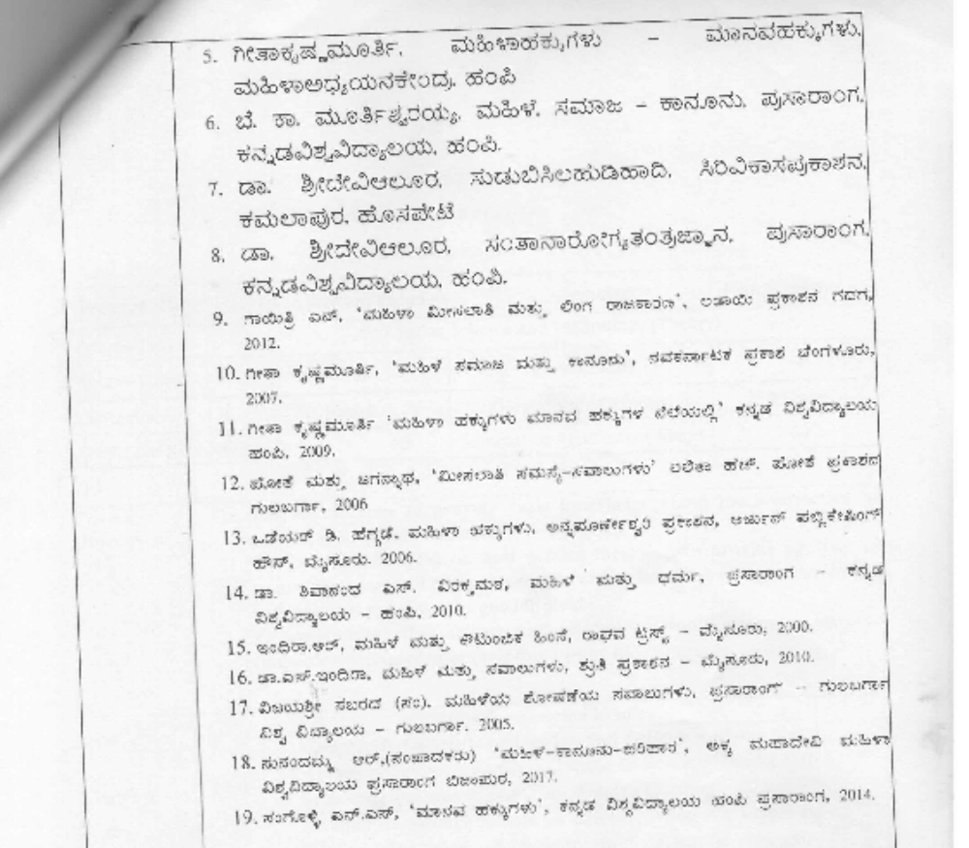
Assessment |  | Weightage | Nature of Assignments
Formative Assessment |  | 40% | Written term paper, Seminar  Presentation, 2 Periodic Tests
Summative Assessment |  | 60% | End Semester Examination

Date: Chairperson

Course Co-Ordinator

MANGALORE UNIVERSITY

Curriculum
Program Name | BA in Women’s Studies |  |  | Semester | Fifth Semester
Course Title | Foundations of Feminist Counselling Techniques (Theory + Practical)
Course Code: | WS C-11 |  | No. of Credits |  | 4
Contact hours | 60 Hours |  | Duration of SEA/Exam |  | 2 hours
Formative Assessment Marks |  | 50 | Summative Assessment Marks |  | 50

Course Objectives: | - The Course aims at understanding Counselling Process  - The Course will help students appreciate Counselling theories and internalize essential counselling skills.  - The Course will give sufficient practical exposure to the students to master gender-inclusive counselling techniques
Content: | Unit-1 | Understanding Counselling from Feminist Perspectives | 14hrs.
Content: | Unit-1 | Chapter-1 Definition, nature and Scope of Counselling, Understanding Counselling as a Process, Meaning, nature, definition, & Scope of Counselling, Personal Characteristics of counsellor  - Professional issues in counselling  - Ethical issues in counselling | 14hrs.
Content: | Unit-1 | Chapter-2 Psychoanalytic Feminism Perspectives – from gender neutral counselling to Gender-sensitive Counselling | 14hrs.
Content: | Unit-1 | Chapter-3 Stages and skills in the counselling process:– ways to initiate communication and build a counselling relationship; core conditions of counselling; ways to enhance communication;  in-depth exploration | 14hrs.
Content: | Unit-1 | Chapter-4 RCI guidelines of counselling, Guidelines for psychological practice with girls and women (American Psychological Society Guidelines) | 14hrs.
Content: | Unit-2 | Process and assessment in counselling | 12hrs
Content: | Unit-2 | Chapter-1 Stages of the counselling interview – Ivey’s Model  Assessment – Personality, Cognition, Screening, and diagnostic tools | 12hrs
Content: | Unit-2 | Chapter-2 Pre counselling considerations – Setting goals,  contraction, informed consent, formulation, and conceptualization | 12hrs
Content: | Unit-2 | Chapter-3 Other components of considerations – Referrals, Confidentiality, verbatim recording analysis, interpretation, termination, reporting, follow-ups | 12hrs

 | Unit-3 | Models and Approaches for Counselling | 18 hrs
 | Unit-3 | Chapter-1 Models – Carl Roger, Eagan, Ivey, and Cormier  - Approaches – Psychoanalytical, Behaviouristic, Humanistic, Existential, Cognitive, Gestalt, and Eclectic approach  - Feminist Approach – The therapeutic relationship in feministic counselling  - Discussion of Power - Dynamics in therapeutic relationship and strategies for empowering clients; intersectionality and inclusivity in counselling; Identification of the effects of stereotypes and bias impacts clients of different castes, classes, gender, and sexuality. | 18 hrs
 | Unit-3 | Chapter-2 Experiments (Students are expected to administer any 6 of the following experiments by selecting a minimum of two experiments from each of the categories)  ASSESSMENT OF PERSONALITY  - EPQ  - 16 PF - Raymond B. Cattell  - Big 5 - John, O. P., &Srivastava, S.  - Anger Expressions - Charles D. Spielberger  - Type A Personality  ASSESSMENT RELATED TO HEALTH  - Students Stress Scale – Manju Agarwal  - Coping Scale - Erica Frydenberg  - Quality of Life - WHO  - Psychological General Wellbeing Index - Olivier Chassany  ASSESSMENT RELATED TO COUNSELLING  - Problem Checklist - Herbert C. Quay  - Study Skills – DrKanchana  - Interest schedule - Sanjay Vohra  - Depression Scale – Beck | 18 hrs
 | Unit-4 | Skill in Counselling | 16hrs
 | Unit-4 | Chapter-1 Micro skills: Basic Communication Skills, Establishing rapport, Attending behavior, Questioning, observation skills, Reflection of content, Refection of feeling, Integrating, Listening skills, Eliciting, Paraphrasing, and Summarizing case  studies | 16hrs
 | Unit-4 | Chapter-2 – Macro Skills in Counselling  Empathy, Self-disclosure, Review, Confronting, Focusing on the interview, Reflection of meaning, Influencing skills, Positive asset search, Capacity building, dealing with transference and Countertransference, and Identification of attitudes and feelings | 16hrs
Practicums | Minimum 30 hrs of the visit to:  - Visit to Child Guidance Counselling Clinic-  - Visit to PPTTC(HIV/AIDS) Counselling centre–  - Visit to Family Counselling Centre-  - Visit the Guidance Counselling Center for victims/survivors of gender-based violence  - Report on activities of Guidance and Counselling
Pedagogy: | Lectures, Case studies of women entrepreneurs, preparing Business proposals, and visiting local enterprises

Course Outcomes (CO’s) | CO1 | Students will be able to explain the meaning, scope, types, and functions of Counselling
Course Outcomes (CO’s) | CO2 | Students will be able to perform gender-inclusive counselling techniques and reiterate the need for counselling women and adolescent girls;
Course Outcomes (CO’s) | CO3 | Students can prepare a model project proposal by taking a critical case study for guidance and counselling.
References/ Readings | - APA GUIDELINES, for Psychological Practice with Girls and Women, (2018), https://www.apa.org/about/policy/psychological-practice-girls-women.pdf  - Gladding 2013; Counselling: A Comprehensive Profession 7th Edition  - Barki B.G. & Mukhopadhyay B 2008 Guidance and Counselling a Manual 10th reprint Sterling  - Augustine Meier, and Micheline Boivin (2010), Counselling & Therapy Technique, Theory and Practice (Sage)  - Rosemary A Thompson (2016). Counselling Techniques-Improving relationships with others, ourselves, our families, and our environment, 3rd ed. Routledge.  - Nelson-Jones (2010). Basic Counselling Skills. Sage Publications.  - Jacobs, M. (2004). Psychodynamic counselling in action. Sage Publications.  - Corey. M. S & Corey G. (2015). Becoming a Helper. Cengage Learning  - Nelson–Jones, R. (2004). Practical counselling and helping skills – Text and exercises for the life skills counselling model, 4th edition, Sage Publications.  - Narayana Rao, “Counselling and Guidance”–2nd Edition, Tata Mc.Graw Hill Publishing Ltd., New Delhi, 2000.  - Masch.“Principles of Guidance and counselling”–Sarupand Sons, New Delhi,2000.  - Sitaram Jayaswal.“Guidance and Counselling–An eclectic approach”– Prakash Kendra, Lucknow,1990.  - Mukhopadhyay,“Guidance and Counselling”– (AM annual), Himalaya Publishing House Ltd., New Delhi, 1989
Assessment |  |  | Weightage | Nature of Assignments
Formative Assessment |  |  | 50%  30 marks for practicals (20 marks report+ 10 marks viva with external examiner)  20 marks for Seminars,  Periodic tests, and attendance | Written term paper/Field Report, Preparing case studies, Seminar Presentation, 2 Periodic Tests
Summative Assessment |  |  | 50% | End Semester Examination

Date: Chairperson

Course Co-Ordinator

MANGALORE UNIVERSITY
Curriculum
Program Name | BA in Women’s Studies |  |  | Semester | Fifth Semester
Course Title | Education: Gender perspectives
Course Code: | WS E-1A |  | No. of Credits |  | 3
Contact hours | 45 Hours |  | Duration of SEA/Exam |  | 2 hours
Formative Assessment Marks |  | 40 | Summative Assessment Marks |  | 60

Course Objectives: | - The course will make students understand and examine the gendered nature of educational transactions as expressed in curriculum, textbooks, and pedagogy.  - The course will help the learner to appreciate the liberating potential of education  - This course helps students understand women’s education in India and Karnataka
Content: | Unit-1 | Prospective women’s education | 16hrs.
Content: | Unit-1 | Chapter-1 Objectives, Significance, and Scope of education  for girls and women Historical perspective of Women’s Education in India Early, Colonial, and Modern Periods | 16hrs.
Content: | Unit-1 | Chapter-2 Constitutional Provision, Committees and Commissions on Women’s Education- Radhakrishnan, Mudaliar, and Kothari Commission, Durgabai Deshmukh Committee, Hansraj Mehta Committee and Bhaktabatsalam  Committee, National Policy of Education- 1968, 1986, 2020 | 16hrs.
Content: | Unit-1 | Chapter-3 Theoretical Background of Women’s Education: Liberal Marxist/Socialist and Cultural Perspectives on gendering education. | 16hrs.
Content: | Unit-2 | Gender Inequality in Education | 14hrs
Content: | Unit-2 | Chapter-1 Issues of access: Unequal access, enrolment, drop out Socio-cultural determinants of Women’s education Infrastructural inadequacies (toilet, female teacher, distance of  the school) | 14hrs
Content: | Unit-2 | Chapter-2 Gendered texts: Curriculum, Textbooks and Teacher’s attitudes and classroom processes, Producing the  Gendered Self, Nurturing Masculinities and Femininities | 14hrs
Content: | Unit-2 | Chapter-3 Primary Education of Girl Child: Problems and Prospects  Higher Education of Women: Changing Status Professional  and vocational education for girls and women Education of the | 14hrs

 |  | Less Privileged Sections of Women Education and female workforce participation
 | Unit-3 | Indian Educational thinkers and philosophers | 15 hrs
 | Unit-3 | Chapter-1 Rabindranath Tagore, Savitribai Phule, Rishi Aurobindo, Mahatma Gandhi, J D Krishnamurti, Devanuru Mahadeva(Essay: Edege Bidda Akkshara) | 15 hrs
Pedagogy: | Lectures/ Assignments/Self-study/Role-play/Poster/And Album Making/  Presentations/Film Review/Group Readings and Discussions
Course Outcomes (CO’s) | CO1 | After completing the course, students can appreciate the gendered nature of the curriculum, textbooks, school processes, classrooms, teacher attitudes, and peer conversation.
Course Outcomes (CO’s) | CO2 | Students will be familiar with critical policies, issues, and debates around gender and education in contemporary India;
Course Outcomes (CO’s) | CO3 | Students will be acquainted with educational philosophies of Indian origin
References/ Readings | - Agarwal, S.P (2001), Women’s Education in India, Guwahati, Eastern Book House.  - Andal, N (2002), Women and Indian Society: Options and Constraints, Guwahati, DVS Publishers.  - Arya Sadhna (1999), Women, Gender Equality and the State, New Delhi, Deep &Deep Publications.  - Seth Mira (2001), Women and Development, New Delhi, Sage Publication  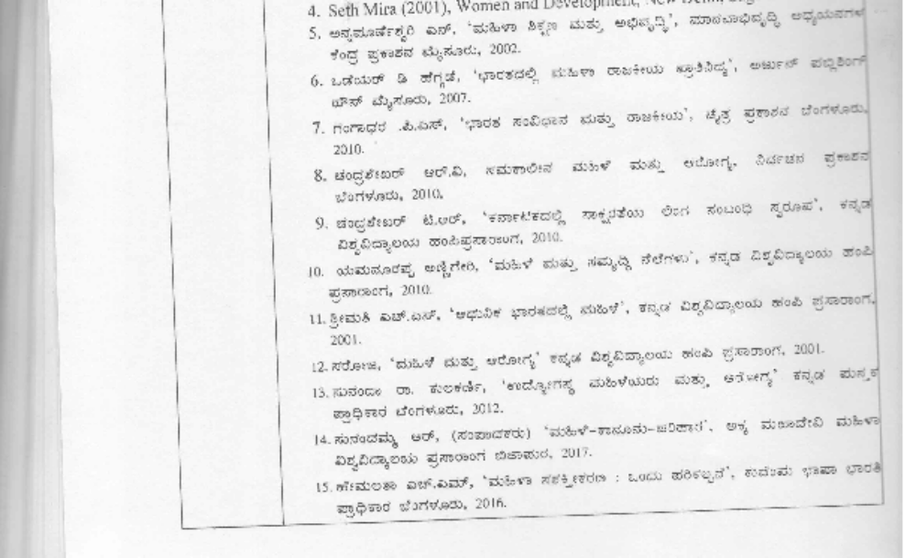

 | 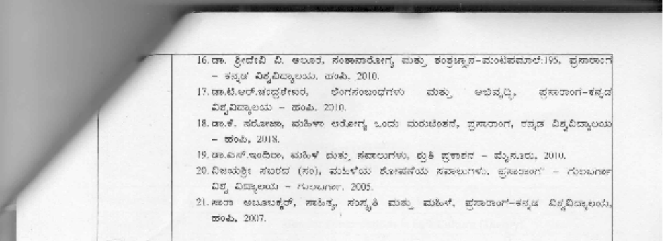
Assessment |  | Weightage | Nature of Assignments
Formative Assessment |  | 40% | Written term paper, Seminar  Presentation, 2 Periodic Tests
Summative Assessment |  | 60% | End Semester Examination

Date: Chairperson
Course Co-Ordinator

MANGALORE UNIVERSITY

Curriculum
Program Name | BA in Women’s Studies |  |  | Semester | Fifth Semester
Course Title | Gender Constructions in Folk Culture (Theory)
Course Code: | WS E-1B |  | No. of Credits |  | 3
Contact hours | 45 Hours |  | Duration of SEA/Exam |  | 2 hours
Formative Assessment Marks |  | 40 | Summative Assessment Marks |  | 60

Course Objectives | - To introduce Karnataka’s rich folk tradition before students  - To make them understand how people learn and internalize folk culture and occasionally challenge their culture.  - To further sensitize students on Gender Construction in folk Culture  .
Content: | Unit-1 | Folklore and Folk Culture | 15hrs
Content: | Unit-1 | Chapter - 1 Introduction to Folklore: Definition of folk,  folklore, characteristics of folklore, functions, the scope of folklore. | 15hrs
Content: | Unit-1 | Chapter – 2 Introduction to Popular Culture and Folk Culture: Meaning and Nature of Folk Culture, Definition, concept and Scope of Popular Culture, Popular Culture and Folklore, Little Tradition,  and Great Tradition. | 15hrs
Content: | Unit-1 | Chapter -3 Genres of Folk Culture  - Oral literature –Haradesi – Nageshi Songs, Myths, Proverbs, and Riddles  - Social Folk Customs, Rituals, and Traditions  - Performing Arts – Parijat, Radhanata, Dappinata  - Life Style | 15hrs
Content: | Unit-2 | Gender Issues and Folk Culture | 16hrs
Content: | Unit-2 | Chapter -1 Introduction to Gender Issues in Folk Culture  Meaning and Nature of Gender Issues  Gender Issues in Folk Literature: Ballads - Kattala Dari Dura-sati Geetegalu - Krishnamurthy Hanur  Oral epic: Bevana Hatti kalammana salu, Siri Kavya, Sankammana salu  Folk poetry: Garati Hadu | 16hrs

Chapter – 2 Women Centric Folk Custom
Devadasi System: Pataradavaru, Jogatiyaru, Basaviyaru, Bala basaviyaru (Patradavaru, Basavi - Shailaja Hiremath)
The transition of Matrilineal Society to Patrilineal Society Matrilineal Family – Bantaru (Banta’s Culture – Surendra Rao) Folk Custom – Marriage, Customs of puberty (Rulumati)
Folk Ritual – Folk Dieties, Karaga Ritual, Gullavana Ritual Karaga Sampradaya - M. Sumitra
Hennu Daivagalu – Shailaja Hiremath Gullvva: Aacharane – Veeresh Badiger Tradition – Siri Tradition
 | Unit-3 | Contemporary Life and Folk Culture | 14hrs
 | Unit-3 | Chapter – I meaning and Nature of Gender Construction in Contemporary Life  Nature of gender construction in folk culture, Gender conflict in contemporary life of folk culture. | 14hrs
 | Unit-3 | Chapter – 2 Family Structure, Ownership, Society Depicted in Folk Culture,  Family structure, Kinship, and societal relationship, Ownership of the family, Male domination of society in folk culture, Symbals of Female importance in folk ritual  Halakki Okkaligaru – N.R Nayak | 14hrs
 | Unit-3 | Chapter – 3 Production Relations and Gender Construction in Folk Culture  Nature of the productions in folk life, Agriculture, Hunting, Food Gathering, Animal husbandry culture, and small-scale trade; Domination of males in production relations; Folk culture encounter with modernity and Globalization; Violence on women in rural areas and metropolitan culture;  Women struggle for socio-economic liberty from the male- dominant imperialist economy.  Folk Culture’s Encounter with Modernity and Globalization | 14hrs
Practicums | - Documenting Folk Literature  - Documenting Field work experience  - Video/ Documentation of Folk Art Performances, Folk Fairs, Customs, Rituals, beliefs and Community Life style
Pedagogy: | Lectures, Case studies of Community and their Culture, preparing synopsis of Folk culture, Watching movies and folk performances, Use of ethnographic and participant observation techniques
Course Outcomes (CO’s) | CO1 | After completion of the course, students will be able to appreciate the influence of folk culture on gender identity construction
Course Outcomes (CO’s) | CO2 | This paper facilitates using feminist ideas and arguments in academic work, making students aware of alternative analysis tools.
Course Outcomes (CO’s) | CO3 | The course will facilitate diverse understanding among students; while students from rural backgrounds will get inklings of their own traditional cultures with a sense of pride and a critical outlook, students from an urban background will come out of their cocoons and understand the complexities of our plural society

References/ Readings | 1. Appadurai, Arjun, Frank J. Korom, Margret A. Mills, 1991 (Ed.) Gender, Genre and Power in South Asian Expressive Traditions, Philadelphia, university of Pennsylvania Press.
 | 2. Claus, Peter J. and Frank J. Korom, 1991, Folkloristic and Indian Folklore,
 | Udipi, Regional Resources Centre for Folk-performing Arts.
 | 3. Dundes, Alan (Ed.), 1964, Text, Texture and Context, in Southern Folklore
 | (quarterly), Vol.28.
 | 4. Kanaka Durga P.S., 2001, Gender Studies on folklore: trends and Prospects in
 | (Ed.) B. Ramakrishna Reddy, Dravidian Folk and Tribal Lore, Dravidian
 | University, Kuppam.
 | 5. Kanaka Durga P.S., 2006, Transformability of Gender roles: Converging
 | Identities in Personal and Poetic Narratives (Eds.) Leela Prasad, Ruth, B.
 | Bottingheimer and Lalitha Handoo, Gender and Story in India, Albany, State
 | University of New Yark Press.
 | 6. Dorson, Richard M., 1972, Folklore and Folklife, Chicago: Chicago University,
 | Press.
 | 7. Shailaja Hiremath, 2022, `Basavi' Reprovincializing Knowledge, Editor:
Tharakeshwar V.B, Prasaranga, Kannada University, Hampi

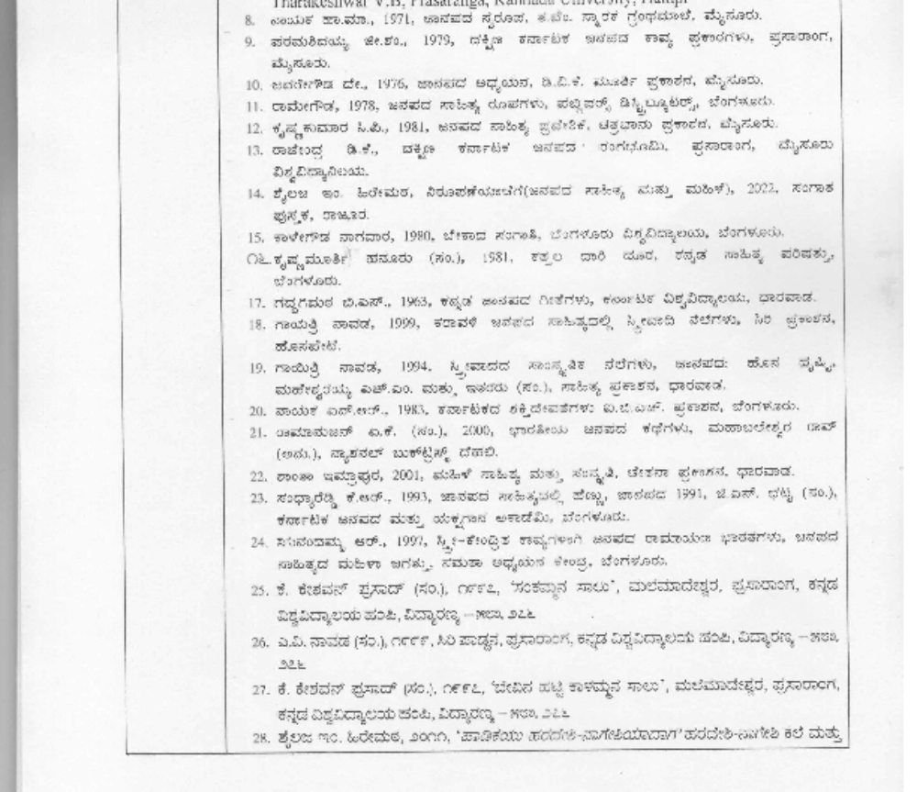

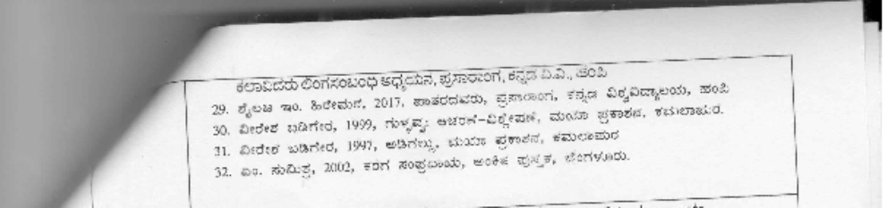

Assenment | Weightage | Nature of Assignments
Formative Assessment | 40% | Written term paper, Seminar  Presentation, 2 Periodic Tests
Formative Assessment | 60% | End Semester Examination

Date: Chairperson

Course Co-Ordinator

MANGALORE UNIVERSITY
Curriculum
Program Name |  | BA in Women’s Studies |  |  |  | Semester | Fifth Semester
Course Title |  | Gender, Entrepreneurship & Skill Development (Theory)
Course Code: |  | WS V-1A |  |  | No. of Credits |  | 3
Contact hours |  | 45 Hours |  |  | Duration of SEA/Exam |  | 2 hours
Formative Assessment Marks |  |  |  | 40 | Summative Assessment Marks |  | 60
Course Objectives | - The course will provide theoretical and conceptual knowledge on Entrepreneurship from gender perspectives  - Recognizing the challenges faced by women entrepreneurs, the course will provide knowledge about the procedures involved in the organization of new enterprises;  - The course aims to generate interest and intends to skill students in the establishment of new organizations
Content: |  |  | Gender & Entrepreneurship |  |  |  |  | 15hrs
Content: | Unit-1 |  | Chapter-1 Entrepreneurs and Entrepreneurship–Qualities of Entrepreneur, Concept, and Definition of Entrepreneurship– Entrepreneurial Functions–origin and Growth of Entrepreneurship  in India |  |  |  |  | 15hrs
Content: |  |  | Chapter-2 Establishing New Enterprises–Choice of Enterprise––  Choice of Technology, Financing, Preparation of the Business Plan. |  |  |  |  | 15hrs
Content: |  |  | Chapter-3 Business Plan for Entrepreneurs– Generating a business idea, developing a Business plan, Market Analysis, Financial Analysis, Realistic planning, Marketing, Costing and Pricing, Operational Management, Record, Keeping, Saving |  |  |  |  | 15hrs
Content: | Unit-2 |  | Women and Entrepreneurship |  |  |  |  | 14hrs
Content: |  |  | Chapter-1 Objectives of Women Entrepreneurship- Gender Culture and entrepreneurship, - Characteristics of women Entrepreneurship, Rural entrepreneurship- EDP programmes- AWAKE |  |  |  |  | 14hrs
Content: |  |  | Chapter-2 Growth of Women Entrepreneurship in India (Recent Trends) – Successful Women Entrepreneurs. |  |  |  |  | 14hrs
Content: |  |  | Chapter-3 Challenges before women entrepreneurs in India: Tough resistance from male counterparts, Limited funding, Lack of access to institutional credit, Work-life balance, Minimal support, Lack of education, Lack of access to Technology |  |  |  |  | 14hrs
Content: | Unit-3 |  | Entrepreneurship Development Skills

 |  | Chapter-1 Meaning of Entrepreneurship Skill  Types of Entrepreneurship Skills: Business management skills, Teamwork, and leadership skills, Communication and listening, Customer service skills, financial management skills, Analytical and  problem-solving skills, Critical thinking skills | 16hrs
 |  | Chapter-2 Entrepreneurship Development Skills: Teamwork and leadership skill, Strategic thinking and planning skills, technical skills, Time management, and organizational skills, Branding, Marketing and Networking skills, IT skill, Entrepreneurial Imagination and Creativity | 16hrs
Practicums | - Collecting Case- Studies of Women Entrepreneurs.  - Visit to Enterprise, owned by women entrepreneurs and a regional support system.  - Preparation of Project Proposal for a Selected Enterprise.
Pedagogy: | Lectures, Case studies of women entrepreneurs, preparing Business proposals, and visiting local enterprises
Course Outcomes (CO’s) | CO1 | After completion of the course, students will be able to define the concept of Entrepreneurship and highlight the qualities and functions of an entrepreneur;
Course Outcomes (CO’s) | CO2 | The course will empower students with the prerequisites to establish new enterprises and prepare a blueprint for the same;
Course Outcomes (CO’s) | CO3 | Students will be analyzing the recent trends in the growth of Women Entrepreneurship and challenges being faced by women entrepreneurs in India;
Course Outcomes (CO’s) | CO4 | Students will be able to assess the management performance and successfully implement the strategies for the stabilization and growth of women enterprises in India
References/ Readings | - Siva Kama Sundari, S. Entrepreneurship development for Rural Women” (Vol.1), Asian and Pacific for Transfer of Technology, New Delhi, 1995.  - Sundara Pandian M. “Women Entrepreneurship: Issues and strategies”, Kanishka Publishers, Distributors, New Delhi, 1999.  - Dorothy P.Moore, E.Holly Buttner , “Women Entrepreneurs-Moving Beyond the Glass Ceiling” Sage publications, New Delhi, 1997.  - Rais Ahamd, Taab Sherwani, Mohammad Irfan Rais, “Women Entrepreneurship Development in India” R.P.Publications, New Delhi, 2018  - E.D.Setty, “Clinical Approach to Promotion of Entrepreneurship among Women”Anmol Publications Pvt Ltd, New Delhi,2004

 | 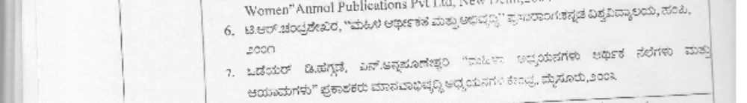
Assessment |  | Weightage | Nature of Assignments
Formative Assessment |  | 40% | Written term paper/Field Report,  Seminar Presentation, 2 Periodic Tests
Summative Assessment |  | 60% | End Semester Examination

Date: Chairperson
Course Co-Ordinator

MANGALORE UNIVERSITY

Curriculum
Program Name | BA in Women’s Studies |  |  | Semester | Sixth Semester
Course Title | Understanding Empowerment from Feminist Perspective (Theory)
Course Code: | WS C-12 |  | No. of Credits |  | 4
Contact hours | 60 Hours |  | Duration of SEA/Exam |  | 2 hours
Formative Assessment Marks |  | 40 | Summative Assessment Marks |  | 60

Course Objectives: | - This course will help students understand the Women Empowerment Approaches in India through the Five-Year Plans  - The course will help students gain insights into Political Empowerment, Economic Empowerment, and Health Empowerment of Women through region-specific strategic interventions in India.  - The course will help students to understand the significance of the Empowerment of specific groups of women and its impact on their lives.  - The course will give exposure to the feminist perspective on Women’s empowerment programs and policies in India
Content: | Unit-1 | Introduction to Empowerment | 14hrs.
Content: | Unit-1 | Chapter 1- Definitions, Dimensions of Empowerment,  Types of empowerments, Roles of Empowerment | 14hrs.
Content: | Unit-1 | Chapter 2 – Empowerment Strategies  Empowerment Process, Indicators of Empowerment (Access to education, labor force participation, participation of women in decision making, women’s access to money and credit, women’s freedom of movement, ownership of assets by women) | 14hrs.
Content: | Unit-1 | Chapter 3- Approaches of Empowerment  - Integrated Development Approach  - Economic Empowerment Approach  - Consciousness Raising Approach  - Research/ Training/Resources Support Approach  - Gender Mainstreaming Approach | 14hrs.
Content: | Unit-2 | Women Empowerment Approaches in India
Content: | Unit-2 | Chapter-1: Interventions for Women’s Empowerment and Gender Equality: Programs for Work and empower women, Gender Analysis, Reducing Drudgery, Awareness of Rights, Equal Leadership, Access to Financial Services, Functional  Adult Literacy, Health Services, Halting Child marriage, Prosecuting Gender-Based Violence

 |  | Chapter-2 Understanding the Changing Dimensions of Women empowerment approaches in India -An Overview of VIIth to XIth Five Year Plan and the Role of NITI Ayog  in Launching the Women Entrepreneurship Platform (WEP) | 16hrs
 |  | Chapter-3: Government Schemes for Women’s Empowerment in India  Mahatma Gandhi National Rural Employment Guarantee Act (MGNREGA), Mahila Samakhya, Gender Budgeting (XI Plan), SIDBI’s Mahila Udyam Nidhi, Crèches/ Day care center, National Mission for Empowerment of Women, Rastriya Mahila Kosh (RMK), Swadhar Greh, Beti Padao Beti Bachao yojana, Working Women Hostel Scheme, One-Stop Crisis Centre Scheme, STEP (Support to Training and Employment Program for Women), Mahila Shakti Kendras (MSK) | 16hrs
 | Unit-3 | Women’s Empowerment in Policy and Practice | 16hrs
 | Unit-3 | Chapter 1- Policies and initiatives of the State and Civil Society organizations/NGOs towards empowering women in  the Socio-Economic, Education, Health, and Political arena. | 16hrs
 | Unit-3 | Chapter-2: Reflections on Implementation of Programs for Empowering Women from various sections of Society (Case Studies)  - Political Empowerment of Women in Local Government (Any local case studies)  - The outcome of women’s development programs towards economic Empowerment. - Reflections from Self Help Groups intervention from Karnataka, Stree Shakti groups, and Kerala’s Kudumbashree yojana  - Health empowerment programs – Case studies Activating village-level monitoring to improve maternal health in Bihar.  - Case studies of empowerment initiatives towards educational upliftment of women across India. | 16hrs
 | Unit-4 | Empowerment as a Feminist Vision of Development | 14hrs
 | Unit-4 | Chapter -1- Feminists’ Perspectives on Empowerment.  - Feminist consciousness-raising and collective action- (Srilata Batliwala, Naila Kabeer) | 14hrs
 | Unit-4 | Chapter-2-Women Empowerment Approaches and the disadvantaged women: Equality vs Equity  Empowerment Approaches for Dalit and Tribal Women in Karnataka | 14hrs
Practicums | Preparation of Locally relevant Empowerment Case-studies
Pedagogy: | Lectures/ Assignments/Self-study/Expert talks/ Poster/And Album Making/Presentations/Film review/Field visits /Group Readings and  Discussions/ Preparing case studies on local women empowerment issues
Course Outcomes (COs) | CO1 | After completing the course, the students should be able to appreciate the meaning and importance of women’s Empowerment
Course Outcomes (COs) | CO2 | The students should also be able to understand the various dimensions of women’s Empowerment and will be able to reflect on

 |  | their knowledge of the empowerment process at the local level towards women’s upliftment.
 | CO3 | The students should be sensitized to the needs of downtrodden and socially excluded women.
 | CO4 | Students should be able to apply feminist approaches to understand the empowerment process in women’s economic, social, and political upliftment at various levels.
 | CO5 | The students should be able to develop a sense of preparedness toward field realities and equip themselves to take up work that calls for social change concerning women.
References/ Readings | - Kabeer, N. (1999). The Conditions and Consequences of Choice Reflection on the Measurement of Women’s Empowerment. Gender, Poverty, and Wellbeing (p. 2). Switzerland: UNRISD.  - Batliwala, S. (1995). Empowerment of Women in South Asia. Bengaluru: National Institute of Advanced Studies.  - Caren, G., Geeta, R., & Aslihan, K. (2006, March). Taking Action to Empower Women: UN Mellinnium Project Report. Global Urban Development Magazine: Building Gender Equality in Urban Life, 2(1).  - Snehendu, B., Catherine, A. P., & Kristine, S. C. (1997, March 19). Empowerment of Women for Health Promotion - A Meta-Analysis. 47th Annual Meeting of the Comparative International Education Society (CIES). Mexico City: Elsevier Science Ltd.  - Stephen, C. (2009, November 16). Feminism and Dalit Women in India. Retrieved from Countercurrents.org: https://www.countercurrents.org/stephen161109.htm  - Sowjanya, T. (2011, September 5). Caste Violence in Dalit Women s Writing A Dalit Feminist Critique,Shodhganga@INFLIBNET. Retrieved January 10, 2019, from https://shodhganga.inflibnet.ac.in/handle/10603/108989: https://shodhganga.inflibnet.ac.in  - Moser, C. (1993). Gender Planning and Development - Theory, Practice and Training. London: Routledge  - Shashank Shekhar Thakur, Aasif Ali Naikoo; Women empowerment and their empowering schemes in India; Department of sociology and social work, Barkatullah University Bhopal 462026 (MP), INDIA https://www.researchgate.net/publication/321965670_Women_empower ment_and_their_empowering_schemes_in_India/link/5a3b7cd50f7e9bbef9 fecc3d/download  - Batliwala, S. (1993). Empowerment of Women in South Asia. New Delhi: Asian-South Pacific Bureau of Adult Education.  - Report of the Working group on Empowerment of Women for the XI Plan; Ministry of Women and Child Development Government Of India https://www.aicte-india.org/downloads/woman_empowerment.pdf  - https://www.researchgate.net/publication/14354763_Empowerment_theory_ research_and_application/link/53e151340cf2235f3529cad5/download  - Bharadwaj, A. (2015, March 23). Oxfam India in Action: Activating village level monitoring to improve maternal health in Bihar. policy-  practice.oxfam.org.uk. Retrieved 11 05, 2017, from https://policy- practice.oxfam.org.uk/publications/oxfam-in-action-activating-village-level-

monitoring-to-improve-maternal-health-347301: https://policy- practice.oxfam.org.uk
20. Development, M. o., & India, G. o. (2006, June 12). Report of the Working Group on Empowerment of Women for XI plan. Retrieved from www.aicte- india.org: https://www.aicte-india.org/downloads/woman_empowerment.pdf
- https://advocacy.thp.org/2011/03/top-ten-interventions-for-womens- empowerment-and-gender-equality/
- Planning, C. (2002-2007). Tenth Five Year Plan. New Delhi: Government of India.
- Shiva Chithappa K (2006). Mahila Sabalikarana vibinna nelegalu, Lakshmi Printers:Mysore.
- Shrimathi. H S (2007) Prasaranga, Mahila Arthikathe, Kannada Vishvavidyanilaya, Hampi
- Chandra Shekar T R (2003), Mahila Arthikathe mathu Abhivruddi.
Prasaranga. Kannada Vishwavidyanilaya, Hampi
- http://egyankosh.ac.in//handle/123456789/2566

 | 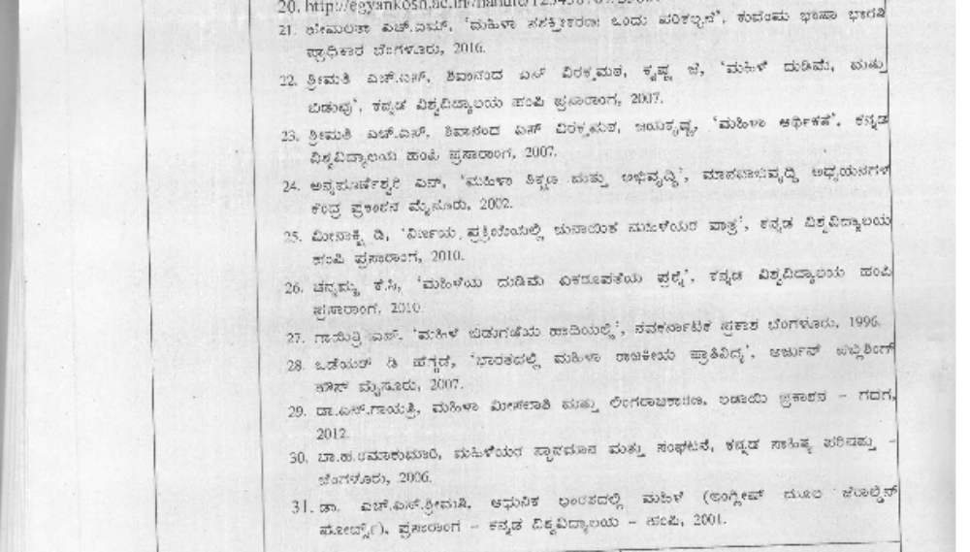
Assessment |  | Weightage | Nature of Assignments
Formative Assessment |  | 40% | Written term paper, Seminar  Presentation, 2 Periodic Tests
Summative Assessment |  | 60% | End Semester Examination

Date: Chairperson

Course Co-Ordinator

MANGALORE UNIVERSITY
Curriculum
Program Name | BA in Women’s Studies |  |  | Semester | Sixth Semester
Course Title | Indian Feminisms (Theory)
Course Code: | WS C-13 |  | No. of Credits |  | 4
Contact hours | 60 Hours |  | Duration of SEA/Exam |  | 2 hours
Formative Assessment Marks |  | 40 | Summative Assessment Marks |  | 60

Course Objectives: | - The course will provide an introduction to the historiography of feminist voices in India  - The course will help students understand the shift in the focus from masculinist male experiences to female ones during the Pre- and post- independence periods.  - The course will help students to understand the emergence of Indian feminist thought with priorities distinctly different from that of the Eurocentric one.  - The course will introduce students to the prominent Indian women in literature and activism who contributed to conscious raising among Indian women’s feminist thoughts and towards global recognition of Indian Feminist thought.
Content: | Unit-1 | Women’s Voice in Ancient India | 16hrs.
Content: | Unit-1 | Chapter 1: Women’s Voice in Ancient Indian Tradition: women in Vedas (Ghosha, Apala, Gargi, Lopamudra, Indrani, and Vishwavara) Women in Epics: Ramayana and Mahabharata  -Women and Smritis: Manusmriti, Yajnavalkya smriti, Katyana Smriti  -Women Kautilya’s Arthashastra | 16hrs.
Content: | Unit-1 | Chapter 2- Women’s Voices in Bhakti and Vachana  Traditions: Meera bai, Andal, Akka Mahadevi, Sancheevanna | 16hrs.
Content: | Unit-1 | Chapter-3 Theoretical Background of Women’s Education: Liberal Marxist/Socialist and Cultural Perspectives on gendering education. | 16hrs.
Content: | Unit-2 | Women’s Voice during the Colonial Period | 12hrs
Content: | Unit-2 | Chapter 1: Women’s Voice during 19th-century social reforms.  Pandita Rama Bai (High caste Hindu Woman) Tara Bai Shinde (Stree-Purush Tulane)  Begum Rokeya Sakhawat Hussein (Sultana’s Dream) | 12hrs

 | Unit-3 | New Intersectional Theoretical Developments | 16hrs
 | Unit-3 | Chapter 1: Post-structural Feminism: Gayatri Spivak (Can Subaltern Speak)  Third World Feminism: Chandra Mohanty (Feminism without Borders, Introduction, Chapter-1) | 16hrs
 | Unit-3 | Chapter 2: Ecofeminism: Environmental Activism, Chipko, Appiko, Narmada and Beyond (Vandana Shiva, Maria Mies)  Kusuma Soraba, Salmaradu Thimakka, Thulasi Gowda | 16hrs
 | Unit-3 | Chapter-3: Dalit Feminism  - Savitri Bai Phule (Kavya Phule)  -Gopal Guru (Dalit Women Talk Differently’ EPW,1994)  -Sharmila Rege (Dalit Women talk differently: A critique of “difference” and towards a Dalit feminist Stand Point Position’, EPW1998)  - Urmila Pawer (We also made History) | 16hrs
 | Unit-3 | Chapter 4: LGBTI/Queer Voice:  Autobiography of Akkai Padmashali | 16hrs
 | Unit-4 | Contribution of Women Activists, Thinkers, and Writers  from India and Karnataka | 16 hrs
 | Unit-4 | Chapter 1:  Vina Mazumdar (Political Ideology of the Women’s Movement’s Engagement With Law), Maitrayee Krishna Raj (women and Science Part-1), Kamala Bhasin (What is Patriarchy?), Madhu Kishwar (Why I am Not a Feminist), Uma Chakravarthy (Gendering Caste), Mary E John (Women’s Studies in India: Introduction), Vijaya Dabbe (Nari Dari Diganta), H S Shrimati(Hennu- Hengasu) | 16 hrs
Pedagogy: | Lectures/ Assignments/Self-study/Expert talks/Poster/And Album  Making/Presentations/Film review/Field visits /Group Readings and Discussions
Course Outcomes (COs) | CO1 | After completion of the course, students will be able to understand some of the significant women’s voices in Indian historiography and the critique of the construction of womanhood through social reform movements.
Course Outcomes (COs) | CO2 | It helps the student to understand the complex intersectional relationships of class, caste, land, and gender in India
Course Outcomes (COs) | CO3 | After completing the course, students can explore the complex debates of contemporary feminism in the country.
References/ Readings | - Chaudhuri, Maitrayee (2004). (Ed.). Feminism in India, Issues in Contemporary Indian Feminism. New Delhi: Kali for Women and Women Unlimited.  - Maduli Thaosen (2017), The Bhakti Movement and Roots of Indian Feminism,  https://feminisminindia.com/2017/04/03/bhakti-movement-women

    - Menon, N. (2004). Recovering Subversion. New Delhi: Permanent Black.
    - Kumar, R. (1998). The History of Doing. New Delhi: Kali for Women.
    - Sita Dhungana (2021), Influence of Smriti Texts to Women Leadership Development in Cooperatives, AMC Journal Link: https://doi.org/10.3126/amcj.v2i1.35790
    - Pandita Ramabai(1887) The High Caste Hindu Women, Final.pdf, https://sahitya.marathi.gov.in/ebooks
    - Chaudhuri, Maitrayee (2011). (First Print, 1993). The Indian Women’s Movement. Delhi: Palm Leaf.
    - Mazumdar, Vina (1994). ‘Women’s Studies and the Women’s Movement in India: An Overview. Women’s Studies Quarterly, 3&4.
    - Mies, Maria (1980). Indian Women and Patriarchy. New Delhi: Vikas.
    - Chandra Talapade Mohanty, Feminism without Borders, https://hamtramckfreeschool.files.wordpress.com/2014/05/mohanty-chandra- feminism-without-borders-decolonizing-theory-
    - Rege, Sharmila (1998). ‘Dalit Women Talk Differently: A Critique of ‘Difference’ and Toward a Dalit Standpoint’. Economic and Political Weekly,33 (44), October 31st -November 6th, WS 39-WS46.
    - Forbes, Geraldine (1999). Women in Modern India. Cambridge University Press.
    - Jasbir Jain, Indigenous Roots of Feminism: Culture, Subjectivity and Agency”
    - Rekha Pande, “Divine Sounds from the Heart— Singing Unfettered in their Own Voices: The Bhakti Movement and its Women Saints (12th to 17th Century)”
    - Kishwar, Madhu. & Ruth, Vanita (1984). (Eds.). In Search of Answers: Indian Women’s Voices from Manushi. London: Zed Books.
    - Jogdand, P.G. (1995).(Ed.). Dalit Women in India: Issues and Perspectives. New Delhi: Gyan Publishing House.
    - Chakravarti, Uma (2003). Gendering Caste. Kolkatta: Stree.
    - Guru, Gopal (1995, Oct. 14-21). ‘Dalit Women Talk Differently’, Economic and Political Weekly, pp. 2548-50.
    - Rege, Sharmila (1998). ‘A Dalit Feminist Standpoint’. Seminar, Nov. 1998, 471.
    - Rege, Sharmila (1998, Oct. 31). ‘Dalit Women talk differently: A critique of “difference” and towards a Dalit feminist Stand Point Position’. Economic and Political Weekly, pp.39-46.
    - Shiva, Vandana (1988). Staying Alive: Women, Ecology and Survival in India. New Delhi: Kali for Women.

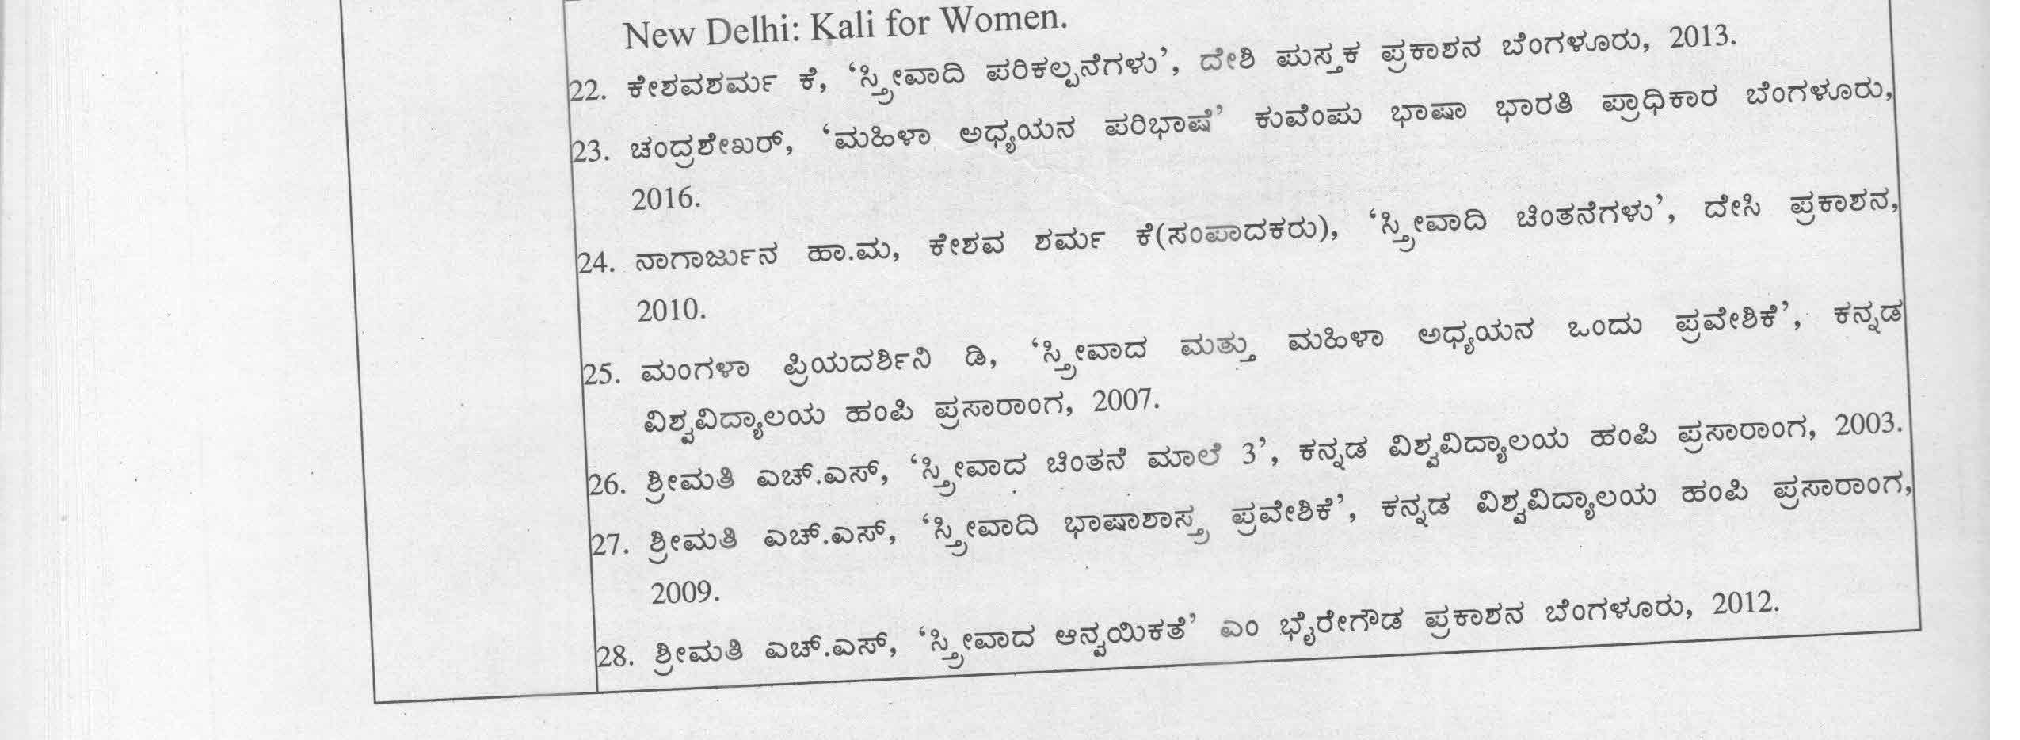

 | 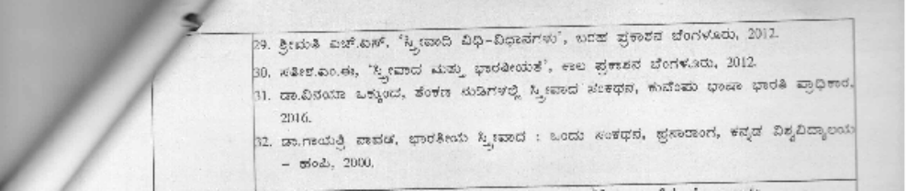
Assessment |  | Weightage | Nature of Assignments
Formative Assessment |  | 40% | Written term paper, Seminar  Presentation, 2 Periodic Tests
Summative Assessment |  | 60% | End Semester Examination

Date: Chairperson

Course Co-Ordinator

MANGALORE UNIVERSITY

Model Curriculum

Program Name | BA in Women’s Studies |  |  | Semester | Sixth Semester
Course Title | Micro Finance & SHG Management (Theory)
Course Code: | WS C-14 |  | No. of Credits |  | 4
Contact hours | 60 Hours |  | Duration of SEA/Exam |  | 2 hours
Formative Assessment Marks |  | 40 | Summative Assessment Marks |  | 60

Course Objectives: | - The course aims to provide students with the principles and practices of microfinance institutions and services.  - The course also emphasizes improving students’ skills to understand microenterprises’ business plans for self-employment opportunities.  - The course will help in understanding the role of microfinance and SHGs in empowering women by providing safety-net and increasing women’s self-employment, thereby maintaining their standard of living
Content: | Unit-1 | Introduction to Microfinance | 16hrs.
Content: | Unit-1 | Chapter-1 Concept and meaning of microfinance, principles of microfinance; microfinance client; microfinance products: microcredit, micro saving, micro insurance, payment, and transfers; and the distinction between traditional financing and micro-  financing, micro credit: elimination of money lenders | 16hrs.
Content: | Unit-1 | Chapter-2 Micro Entrepreneur and Microfinance Concept and importance of micro enterprises and entrepreneurs; business plan for micro enterprises, preparation of business plan.  Objectives of the microfinance institutions: Importance of microfinance institutions; attributes of a good microfinance institutions; | 16hrs.
Content: | Unit-1 | Chapter-3 Microfinance Credit Lending Models: Individual lending model; Grameen Bank solidarity lending model; village banking model; cooperative model; self-help group model; rotating savings and credit association. Evolution- Status of microfinance in India, Role of banks in micro finance and micro credit | 16hrs.
Content: | Unit-2 | Self-Help Group Management | 16hrs
Content: | Unit-2 | Chapter-1 Self Help Groups & Women- concept- Definition-  Evolution-Group Formation- solidarity groups, Gender sensitization, and building women’s agencies | 16hrs
Content: | Unit-2 | Chapter-2 Activities of Self-Help Groups: Savings, credit, marketing, and insurance- Revolving Fund-SHG-Bank Linkage- | 16hrs

 |  |  | SHG federations- Micro enterprises & SHGs- SHGs in Dairy Sector-Management of SHGs
 |  |  | Chapter-3 Opening Account- Book Keeping-Conducting Meetings-Record Keeping- Loans- activity management- Leadership-Role of SHGs in rural development & Social Change
 | Unit-3 |  | Role of Micro-Finance and SHG in Women’s Empowerment | 14hrs
 |  |  | Chapter- 1 Women’s Empowerment: Concept of social capital-  - Promotion of Self-help Groups | 14hrs
 |  |  | Chapter-2 Role of Micro Finance and SHGs in women’s empowerment: Women economic Independence-Decision making skills, using Banking facilities, Social upliftment, political mobility.  Micro Finance & Poverty Alleviation | 14hrs
 |  |  | Chapter-3 Need for regulation: Regulations of the microfinance industry and small enterprises, Sources and process of microfinance; Challenges and difficulties in the process; Cost of finance: interest rate, subsidy schemes, plans, transaction costs for micro-entrepreneurs. Challenges in costs and interest rate, and way outs.  Microfinance: Empowering women or Increasing Loan burdens SHG: women’s Access and Control analysis of funds received through SHGs | 14hrs
 | Unit-4 |  | Policies and Programs related to Microfinance and SHG | 14
 |  |  | Chapter-1: Kudumbashree mission in Kerala, SHGs Bankd linkage  Program (SBLP), NABARD, Rashtriya Mahila Kosh, SEWA, Myrada. | 14
 |  |  | Chapter-2 SHG initiatives in Karnataka: Stree Shakti- Women & Child Development Department- DAY-NRLM-DAY-NULM- Interest Subvention schemes | 14
Practicums | - Collecting Case- Studies of Women SHGs  - Interacting with Micro-finance groups to prepare a SWOT analysis of the system  - Visiting WCD, Social Welfare Dept, and leading NGO’s supporting SHG practices
Pedagogy: | Lectures, Case studies of women entrepreneurs, preparing Business proposal and visiting local enterprises
Course Outcomes (COs) | CO1 | After completion of the course, students will be able to explain the nature of microfinance and microfinance models.
Course Outcomes (COs) | CO2 | The course will empower students to identify the role of microfinance institutions and SHGs in social and economic development of women
Course Outcomes (COs) | CO3 | Students will be able to analyse the recent trends in growth of micro- finance and SHGs and challenges being faced by women in India and Karnataka

 | CO4 | Students will be able to Develop the ability to conduct the case studies of microfinance institutions and Self-help groups.
References/ Readings | - Yunus.M., Rural Agricultural Credit Operations in Bangladesh  - Femandes AP The MYRADA Experience-Alternative management systems for saving and credit of Rural Poor.  - Ila Bhat, A Bank of One’s Own (A note from SEWA) Finance against poverty  - Rajashekhar. D. Savings and Credit Systems of the poor: Some NGO experiences, NOVIB and HIVOS  - D.Rajasekhar and Mahadeswaran (2005). Ecoomic and Social Benefits of Micro-Finance programmes in BB Bhattacharya and Arup Mitra (eds.) Studies in Macroeconomic and Welfare, New Delhi: Academic Foundation.  - Hisrich, R. D. Peters, M. P & Shepherd, D. A. Entrepreneurship. New Delhi: Tata McGraw Hill Education.  - Hisrich, R. D. Peters, M. P & Shepherd, D. A. Entrepreneurship. New Delhi: Tata McGraw Hill Education.
Assessment |  |  | Weightage | Nature of Assignments
Formative Assessment |  |  | 40% | Written term paper/Field visit Report, Seminar Presentation/Case studies,  2 Periodic Tests
Summative Assessment |  |  | 60% | End Semester Examination

Date: Chairperson

Course Co-Ordinator

MANGALORE UNIVERSITY
Curriculum
Program Name | BA in Women’s Studies |  |  | Semester | Fifth Semester
Course Title | Feminization of Poverty (Theory)
Course Code: | WS E-2A |  | No. of Credits |  | 3
Contact hours | 45 Hours |  | Duration of SEA/Exam |  | 2 hours
Formative Assessment Marks |  | 40 | Summative Assessment Marks |  | 60

Course Objectives | - To enable students to understand the concepts of Poverty from multiple intersectional dimensions.  - To understand the causes and impact of Poverty on the lives of women.  - To enable students to think, analyze and find the solution for the Feminization of Poverty.
Content: | Unit-1 | Understanding and Analyzing the Concept of Poverty | 16hrs.
Content: | Unit-1 | Chapter-1 Poverty- Meaning and Definition, causes, types, and  Levels | 16hrs.
Content: | Unit-1 | Chapter-2 Different Dimensions of Poverty – Social, Economic, Political, Cultural, and Geographical | 16hrs.
Content: | Unit-1 | Chapter-3 Theories of Poverty: Theory of Behavior, Structural and Political Theory. Theory of Individual Deficiencies. Theory of cultural belief. Theory of Economic and Social Distortion. Theory of Geographical disparities. Theory of Cumulative and Cyclical Dependencies | 16hrs.
Content: | Unit-2 | Feminization of Poverty(FOP) | 16hrs
Content: | Unit-2 | Chapter-1 Feminist Approach to Poverty: Gender Implications and social costs of Poverty, Understanding of pervasive intersectional gender inequalities and biases render women more  vulnerable than men to Poverty, | 16hrs
Content: | Unit-2 | Chapter-2 Contributing factors of FOP: Growth of female- headed households, Intra-household inequalities and bias against women and girls, Neoliberal economic policies, including structural  adjustments and the post-socialist market transitions | 16hrs
Content: | Unit-2 | Chapter-3 Vulnerable Women: Female-Headed Families, Women Elders, Single Women, Women with Disabilities, Dalit and Tribal Women, Migrant Women | 16hrs

 | Unit-3 | Global and National Scenario of Feminization of Poverty
 | Unit-3 | Chapter-1 Gendered understanding of Poverty at Global level, Poverty in India and Karnataka
 | Unit-3 | Chapter-2 Government schemes and programs for alleviation of Poverty in general and women in particular in India and Karnataka
Pedagogy: | Poster making by students, Prepare balanced Diet chart. Report writing on local availability.  Visiting local Anganwadi and PHC, Nutrition mapping of women and children in family, Community
Course Outcomes (Cos) | CO1 |  | Students will realize how Poverty affects women locally, provincially, nationally and internationally and why women experience Poverty at higher rates and suffer the effects of Poverty.
Course Outcomes (Cos) | CO2 |  | After completion, Students will understand that pervasive gender inequalities and biases within households, labor markets, legal codes, and political systems throughout the world, render women more vulnerable than men to Poverty.
Course Outcomes (Cos) | CO3 |  | The course will bring awareness on various poverty alleviation schemes in Karnataka and in India
References/ Readings | - Abhijit Vinayak Banarjee, et al, Poverty and income distribution in India, With a new essay by Amartya Sen, 2019  - Kakali Chakrabarty, Women, Poverty and Rural Development, Study on Women in Rural India, Anthropological, Survey of India, Kolkata, 2011 3.Mukesh Eswaran, Why Poverty persists in India a framework for understanding the Indian economy, Oxford University Press, 1997
Formative Assessment |  |  | Weightage | Nature of Assignments
Internal Assessment |  |  | 40% | Written term paper, Seminar  Presentation, 2 Periodic Tests
Summative Assessment |  |  | 60% | End Semester Examination

Date: Chairperson

Course Co-Ordinator

MANGALORE UNIVERSITY

Curriculum
Program Name | BA in Women’s Studies |  |  | Semester | Sixth Semester
Course Title | Gendering Food and Nutrition (Theory)
Course Code: | WS E-2B |  | No. of Credits |  | 3
Contact hours | 45 Hours |  | Duration of SEA/Exam |  | 2 hours
Formative Assessment Marks |  | 40 | Summative Assessment Marks |  | 60

Course Objectives: | - To enable students to understand the importance of nutritional food.  - To provide knowledge about the nutritional values of local/regional food.  - To understand the significance of women’s health from the individual and society’s point of view.  - To enlighten the students about the need to improve the quality of life of women
Content: | Unit-1 | Food, Nutrition, and Health | 16hrs.
Content: | Unit-1 | Chapter-1 Concept Nutrition and Health – Interrelationship  between Health and Nutrition. Nutrition and health status of women and children in India. | 16hrs.
Content: | Unit-1 | Chapter-2 Classification of food and their sources: Proteins, Fats, Carbohydrates (sugars, dietary fiber), Vitamins, and Minerals | 16hrs.
Content: | Unit-1 | Chapter-3 Nutrition and Diet during Infancy, childhood, Adulthood, Young Women, Middle Age, and Elderly | 16hrs.
Content: | Unit-1 | Chapter-4 Balanced diet- Concerning the local availability of food with particular reference to the importance of organic food, millets, and locally available fruits and vegetables | 16hrs.
Content: | Unit-2 | Common Nutritional disorders among women and children in  India | 14 hrs
Content: | Unit-2 | Chapter-1 Socio-cultural and economic factors affecting food preparation and intake. Gender bias in providing food to children and health care in the family | 14 hrs
Content: | Unit-2 | Chapter-2Food- availability of grains and other ingredients - Preparation, distribution and intake – gender analysis | 14 hrs
Content: | Unit-2 | Chapter-3 Symptoms and nutritional sources for the following nutritional deficiencies: Iodine, Vitamin-A, Vitamin B-12, Vitamin D, Iron, Calcium, Vitamin B-9(Folic Acid), Selenium, Magnesium | 14 hrs
Content: | Unit-3 | Government Interventions for Women’s Health and Nutrition
Content: | Unit-3 | Chapter-1 Concepts of food security, Govt Policies and programs related to women’s health and nutrition – PHC, ICDS, National  Health Policy. National Nutritional Policy, Mid-day Meals,

 |  | Maternal Diet and Nutritional support schemes by Central Govt and Karnataka State Government |  |  |  | 15hrs
 |  | Chapter-2Malnutrition - Girls Pregnant Women in border areas and backward districts, Case Studies of Scheduled Caste /Scheduled Tribe and Nomadic Community |  |  |  | 15hrs
 |  | Chapter-3Health Education  Health Care Services– Sub Center Level, PHC, CHC  ANC, ASHA, and Anganwadi Workers and Their Role in Heath and Nutritional Support for Women and Children |  |  |  | 15hrs
Pedagogy: | Poster making by students, prepare a balanced Diet chart—report writing on local availability.  Visiting local Anganwadi and PHC, Nutrition mapping of women and children in family, Community
Course Outcomes (CO’s) | CO1 |  | The course will facilitate the students to understand the Inter- relationship between food and nutrition.
Course Outcomes (CO’s) | CO2 |  | Students may gain awareness about Gender bias in nutrition intake, home food, organic food, and the medical importance of local food.
Course Outcomes (CO’s) | CO3 |  | The students will know the accessibility of health care services and critical issues in women’s health.
Course Outcomes (CO’s) | CO4 |  | Students will be able to plan a balanced diet needed at different stages of the life cycle of women
References/ Readings | - Gopalan.C. and S Kaur: Women and Nutrition in India Special Publication Series New, Delhi, NFI 1989  - Hirmani A.B: Health Education Media in India Central Health Education Bureau. 1991  - Swaminathan M.: Principles of Nutrition and Dietetics, The BPP Co.Ltd. 1986  - Shukla P.K.: “Nutritional Problems in India.” Prentice Hall of India, New Delhi. 1982  - Govt. of India– National Population Policy”, Document (New Delhi: Ministry of Health and Family Welfare, India –2000).  - United Nation – “IPCD Report –Cairo” (New York: UN1994).  - I.C.S.S.R.– “Health for all–an Alternative Strategy” (Pune, Indian Institute of Education,1981).
Assessment |  |  |  | Weightage | Nature of Assignments
Formative Assessment |  |  |  | 40% | Written term paper, Seminar Presentation, 2 Periodic Tests
Summative Assessment |  |  |  | 60% | End Semester Examination

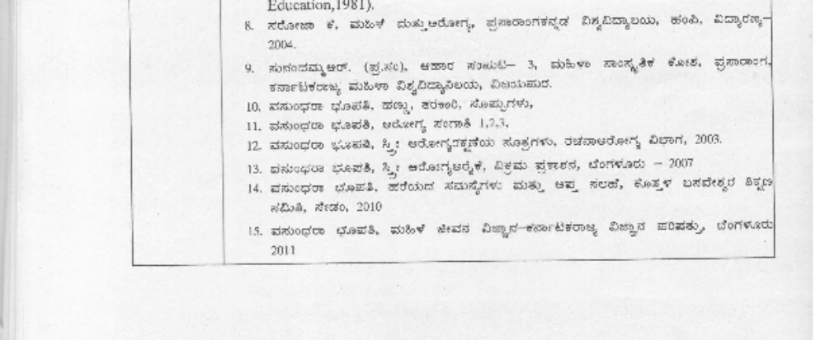

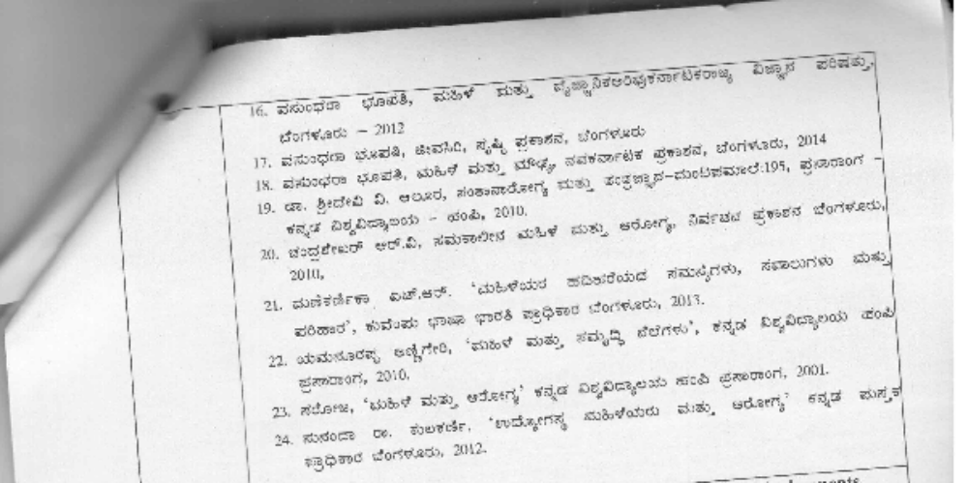

Assessment | Weightage | Nature of Assignments
Formative Assessment | 40% | Written term paper, Seminar Presentation, 2 Periodic Tests
Summative Assessment | 60% | End Semester Examination

Date: Chairperson

Course Co-Ordinator

MANGALORE UNIVERSITY
Curriculum
Program Name | BA in Women’s Studies |  |  | Semester | Fifth Semester
Course Title | Women in Livestock Management (Theory +Practical)
Course Code: | WS V-2A |  | No. of Credits |  | 3
Contact hours | 45 Hours |  | Duration of SEA/Exam |  | 2 hours
Formative Assessment Marks |  | 50 | Summative Assessment Marks |  | 50

Course Objectives: | - To make students understand the nature and scope of livestock development and Management for the agrarian Indian Economy  - To provide knowledge on livestock as an alternative source of Livelihood and women’s empowerment  - To identify the invisible contribution of women in livestock development
Content: | Unit-1 | Role of Live Stock Development in the Indian Economy | 16hrs.
Content: | Unit-1 | Chapter-1 Concept of Development, social and economic development; Historical Overview of Rural Development in India, Livestock: Definition, Importance, Issues, and Scope.  Role of Livestock in Indian Economy, alternative for Livelihood in rural areas | 16hrs.
Content: | Unit-1 | Chapter-2 Important exotic and Indian breeds of cattle, buffalo, sheep, goat, and pig, Selection, and breeding of livestock and poultry for improved production  - General information about reproductive behavior (like oestrus, gestation, parturition) and artificial insemination and measures to improve reproductive efficiency  - Feeds and feeding and care management of animals  - Introduction to livestock and poultry diseases, prevention (including vaccination schedule) and control of important diseases of livestock and poultry | 16hrs.
Content: | Unit-1 | Chapter-3 Economics of Livestock and poultry production, Management of Labor | 16hrs.
Content: | Unit-2 | Women in Livestock management | 14hrs
Content: | Unit-2 | Chapter-1 Women Self Help groups and livestock development, Women empowerment and capacity building, activity profile and time spent by women in livestock rearing-  cow, sheep, buffalo, and poultry | 14hrs
Content: | Unit-2 | Chapter-2 Women in Dairy Farming: Women in Cooperatives movements, Gender Bias in livestock rearing and  Management. KMF-contribution of women. | 14hrs

 |  | Chapter-3 Problems Associated with Women and livestock rearing: Lack of Data on Women in the livestock economy, Lack of Training, Difficulty to avail loans, Lack of technical knowledge, No active role in cooperatives
 | Unit-3 | State Interventions for Livestock Development | 15 hrs
 | Unit-3 | Chapter-1 The National Livestock Policy (NLP), Ongoing Animal Husbandry Development programming – NPCBB, PM assistance livestock development program, rural development  programs with particular reference to livestock SGSY, EGS | 15 hrs
 | Unit-3 | Chapter-2 Transfer of technology (TOT) programs of ICAR- National Demonstration, Krishi Vigyan Kendra, Trainers` Training Centres, Lab to Land program, Operational Research project, National Agricultural research project, Agricultural Technology Management Agency, National Agricultural Innovative project. • Understanding the functioning of livestock development institutions –DRDA, NABARD,  Insurance Companies, NGOs. | 15 hrs
 | Unit-3 | Chapter-3 Different laws governing the livestock sectors to produce quality products on par with international standards – Technique of harvesting clean and hygienic livestock products | 15 hrs
Practicums | Visiting KMF and other farms, preparing Case studies. Visit govt departments and collect information on schemes related to women and livestock development.  Visit Dairy and Other Livestock Farms and Preparation of Report.
Pedagogy: | Lectures/ Assignments/Self-study/Visiting livestock farms, Interacting with  women livestock entrepreneurs
Course Outcomes (CO’s) | CO1 | The course will generate attention to the need for creating greater awareness and cultural sensitivity of livestock.
Course Outcomes (CO’s) | CO2 | Students will learn the various skills and strategies in livestock management and how that can facilitate women’s empowerment
Course Outcomes (CO’s) | CO3 | The students will generate awareness in their respective native villages
References/ Readings | - Mishra, S.N.Livestock planning in India, Vikas publishing house pvt. Ltd. New Delhi, 1978.  - Ramkumar, S and Rao S.V.N. Women self-help groups and cattle rearing, Rajiv Gandhi College of Veterinary and Animal Sciences, Pondicherry, 2007.  - Washington ochole Pascal Sanginge Isaace Belkalo(Ed), Managing Natural Resources for Development in Africa A Resource book, Co-published by University of Nairobi  - Czech Conroy participatory Livestock Research https://doi.org/103362/97817- 8044031  - IFAD www.ifadiorg/lrkn/ index.htm  - Livestock &Women’s Lived hoods: A Revive of the Relent Evidence http://cgspace,cigar, org/paperzo  - Pakistan Muhammad Shadiq, Analysis of the role of women in livestock Production Baluchistan, Https:// www.researchgate. net/publication

- Dahd.nic. Department of Animal Husbandry and Dairying
- Extention Techniques for Livestock Development

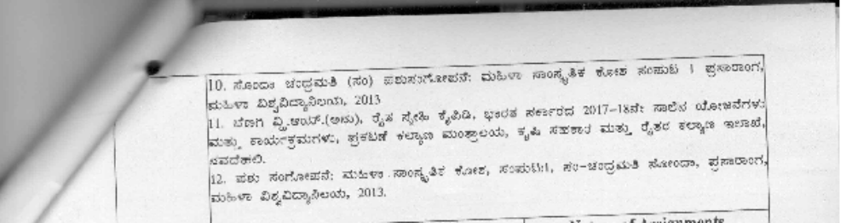
Assessment |  | Weightage | Nature of Assignments
Formative Assessment |  | 50%  30 marks for practicals (20 marks for report+, 10 marks viva with external examiner)  20 marks for Seminars,  Periodic tests, and attendance | Written term paper/Field Report, Preparing case studies, Seminar Presentation, 2 Periodic Tests
Summative Assessment |  | 50% | End Semester Examination

Date: Chairperson

Course Co-Ordinator

MANGALORE UNIVERSITY

Curriculum
Program Name | BA in Women’s Studies |  |  | Semester | Sixth Semester
Course Title | Internship for Under-Graduate Programme (Practical)
Course Code: | Internship |  | No. of Credits |  | 02
Contact hours | 90 Hours |  | Duration of SEA/Exam |  | 2 hours
Formative Assessment Marks |  | 50 | Summative Assessment Marks |  | NA

Internship [Organizational work] is an integral part of the any Education policy for up skilling. Internship is learning through doing. Its objective is to equip students with job skills and communication abilities, enabling them to bridge the gap between theoretical knowledge and practical application. The internship program incorporates various interventions that offer students exposure to real-life job experiences and expectations, empowering them with insights into the workings of different industries, organizations, NGOs, etc.

The internship is strategically positioned during the 6th semester of the Bachelors of Arts in Economics program. This provides students with a strong foundation in respective subjects, enabling them to apply their learned knowledge into real-world settings. Additionally, the program caters to the critical need for 21st century global skill sets to build their life. Overall, the internship program aims to prepare students for the job market, thereby bridging the gap between academia and the professional world.

OBJECTIVES:

- To boost students' employability by imparting soft skills that are essential in everyday life.

To enable students, discover their professional strengths and weaknesses and align them with the changing economic environment.
- To provide an opportunity for students to apply theoretical concepts of gender studies and knowledge in real life situations and at the work place.

To prepare students to understand organization culture and familiarize them with the organization needs.
- To enable students to manage resources, meet deadlines, identify and undertake specific goal-oriented tasks.

To sharpen domain knowledge and provide core competency skills.
- Developing the passion for their professional life.

Internship Requirements & General Guidelines:

  - Nature of internship project work:
    - Every Student is required to work in an organization (a Business firm, NGO, Self- Help Groups/Cooperatives/Farms or any Rural – Urban economic entity components) for at least two months as part of Internship.
    - The student shall identify an internship organization and work place. Principal/Head of Department will facilitate students for internship.
    - Maximum five students of the same department from a College/University shall work for Internship in the particular said organization.
    - Internship work may be to carry out Professional work and enrich the life opportunities.
    - The internship shall be paid or unpaid.

Duration of Internship:

    - The Internship works shall be for a period of One month [Thirty Days including Holidays] between two semesters of fifth and sixth, (it should commence from the last day of exam of fifth semester and must end before the commencement of Sixth semester).
    - Student is expected to carry out his/her Internship works during the first FIVE (05) days of the week, and shall report to the department subject mentor as agreed on a weekly basis.
    - The nature, type and duration of the work shall be specified by the organization at the beginning of the internship and the number of hours spent shall be in line with the prevailing rules.
    - Students are expected complete minimum 90hrs or more with internship organization

Guide and Mentor:

    - An internal mentor shall be assigned by the Principal/Head of Department for the smooth conduct and supervision of the internship program.
    - The internal mentor shall provide guidance students in securing internship and to monitor the progress.

Protocol of the Internship:

    - The head of the institution shall issue a request letter for each student of the concerned department for an internship work and authorization letter (MOU with Agency for Internship) during the 5th semester. (Format of MOU with Agency for Internship enclosed).

    - Every College/Institution should have its exhaustive list of a Business firm, NGO/CSOs, Self-Help Groups/Cooperatives/Farms or any Rural – Urban economic entity components for Internship. Institutions are encouraged to explore internship avenues in relevant government departments. (In present case Women and Child development, Social Welfare, Health, Education, Rural Development and Panchyathi Raj, Police)

    - Every student shall approach various organizations and get confirm for internship. Student shall obtain Internship authorization letter, same shall submit to the college with acknowledgement.

    - Student must submit the joining report with the date of joining for internship to the Principal/Head of Department.

    - The student is expected to be regular in performing his/her duties/tasks assigned to him/her by the Organization.

    - College shall provide orientation to students about internship, schedule preparation, nature of preliminary work in the organization, code of conduct and finishing the internship.
    - Visits by faculty mentor/advisor, checking students’ progress, follow-up, assessing weekly reports and guiding for upgrading skills,
    - Organization/Agency feedback, students report compilation, submission and arranging their presentations and viva-voce examination.

Code of conduct

    - As a student: Punctuality, accountability, proper manners, appropriate dress code, no compensation, timely submission, following rules & regulations of industry/corporate/bank/NGO, be in the Organization/agency.
    - As a staff: Following work-ethics, no involvement in agency politics, maintain confidentiality, no favoritism and unbiasedness.

Evaluation:

    - All the students should obtain a certificate of internship from the workplace. This certificate shall mention the name of the candidate, the organizations name and duration of work. A letter describing the work of the candidate is desirable. The certificate shall be submitted to the department head.

    - The performance of a candidate shall be assessed for maximum of 50 marks.

    - The assessment methods shall be as per appropriate boards of the university/regulation.

    - The assessment method shall consist of an internship report submitted by the students based on the work experience and a viva-voce/presentation.

    - Viva-voce/Presentation: There shall be a viva-voce examination will be conducted for by the department where each student is expected to give a presentation and submit necessary documents.

Rubrics for Understanding:

Attendance
- Never absent
- Dependable
- Usually dependable
- Is not regular enough
- Too many absences

Punctuality
- Always on time
- Seldom comes late
- Needs improvement
- Very often tardy
- Tardiness affects performance

Appearance (clothing/hygiene/hair)
- Always dressed appropriately
- Is good in appearance/frequently but not always dressed appropriately
- Should make more efforts to improve
- Frequently dressed inappropriately
- Often neglects appearance/dressed inappropriately most of the time
- Is extremely careless

Initiative/Motivation
- Is resourceful, looks for things to do
- Is fairly resourceful
- Does acceptable routine work
- Takes very little initiative, requires urging
- Shows no initiative at all

Professionalism
- Consistently demonstrates professionalism
- Usually demonstrates professionalism
- Occasionally demonstrates professionalism
- Rarely demonstrates
- Is totally unprofessional

Courtesy
- Is very courteous and is very consistent
- Is courteous
- Usually courteous and consistent
- Is not courteous
- Very discourteous and inconsiderate

Attitude
- Always positive
- Usually positive
- Rarely positive
- Negative
- Openly hostile and negative

Cooperation
- Works willingly with others
- Usually gets along with others
- Prefers to work alone
- Does not work well with others
- Is antagonistic

Work Habits
- Is industrious, stays on the task till complete
- Seldom wastes time, is reliable
- Is usually reliable
- Frequently wastes time
- Work is often incomplete

Accuracy of Work
- Does work of a very good quality
- Makes few errors
- Often makes errors
- Is frequently inaccurate and careless
- Is extremely careless

Communication
- Excellent communication skills
- Above average communication skills
- Average communication skills
- Need to improve communication skills
- Ineffective communication skills

Adaptability
- Is adept to meeting changing conditions
- Adjusts readily
- Needs direction to make adjustments
- Has difficulty adapting to new situations
- Cannot adjust to changing situations

Internship Assessment by Supervisor/Mentor

Name of Intern Student:

Name of Supervisor/Mentor:

Please rate your intern’s performance in the format given below: A- Excellent-5
B- Very Good-4
C- Average-3
D- Clearly below average-2
E- Unacceptable1

Sr. No | Item | Rubrics for Understanding |  |  |  |  |  | Score for main items | Comment  /Remark
1. | Job attitude
 | Is enthusiastic
 | Is cooperative
 | Is well mannered
 | Is culturally respectful
2. | Initiative
Is able to work with
minimal appropriate supervision
Completed tasks without
being told
 | Is eager to improve
Seeks assistance when
needed
Follows through on
suggestions
3. | Dependability
 | Follows direction
 | Is prompt
Is consistent in
attendance
 | Meets obligations
4. | Adaptability
 | Learns routine quickly
Can move to new tasks
and adapts easily

5. | Team work
 | Works as a team member
 | Gets along with others
Ability to use assistive techniques/device/equipm
ent to meet goal
Ability to collaborate in providing interdisciplinary interventions and
programmes
6. | Communication Skills
Demonstrates accuracy and clarity in written and
verbal communication
Writes appropriately for
the situation
Speaks appropriately for
the situation
 | Uses proper punctuations
 | Spells words correctly
Does not use
abbreviations/slang words
Works with appropriate
media
7. | Organization
Organizes her time
efficiently
Organizes her workplace
efficiently
Administers
resources/funds efficiently
 | Punctual
8. | Group Participation
Prepares materials for
work arising/topic in a group
Demonstrates personal
preparation
Presents material to meeting/group in a clear
and interesting manner
Participates in small group
discussion

Takes conscious and
accurate notes during meeting
 | Follows up on agenda
9. | Stress Management
 | Takes appropriate break
Delegates responsibility
wherever appropriate
Handles conflicts/difficult
situations appropriately
Sets priority, time line and
bench marks
10. | Personal Development
Displays a positive personal philosophy of health, health education
and promotion
 | Exhibits confidence in self
 | Displays resourcefulness
Assumes responsibility
with enthusiasm
Demonstrates appropriate
level of confidence
Dresses appropriately and
efficiently
 | Maintains confidentiality
Accepts constructive criticism and positive feedback concerning
performance
Shows sensitivity to clients, colleagues and
support staff
Demonstrates knowledge of accepted of ethical
conduct

Final Statement of Marks Secured for Internship
Item Particulars | Maximum Marks 50 | Marks Obtained
Job attitude | 05
Initiative | 05
Dependability | 05
Adaptability | 05
Team work | 05
Communication Skills | 05
Organization | 05
Group Participation | 05
Stress Management | 05
Personal Development | 05
Total | 50

Signature of Supervisor/Mentor Date and Seal

Appendix A

Internship registration form for student

- Name of the student:
- Address:
- Contact No.:
- Email:
- Name of the Agency Supervisor:
- Contact No.:
- Date of joining the agency for internship:
- Date of Completion of Internship:

Signature of Student Agency Head Faculty

MOU with Agency for Internship

This MOU is between Principal of the college: & Name of the Agency:
  - The intern student will work in the agency as per the norms developed for internship by the respective University.
  - The intern student will work in the agency as per the duties/work assigned by the agency as per the discussion between the faculty advisor & agency supervisor.
  - University/College will not pay any money towards internship.
  - The intern will follow the agency timings & pattern of work.

Signature of HOD: Signature of Fieldwork Supervisor

Date: Chairperson

Course Co-Ordinator

